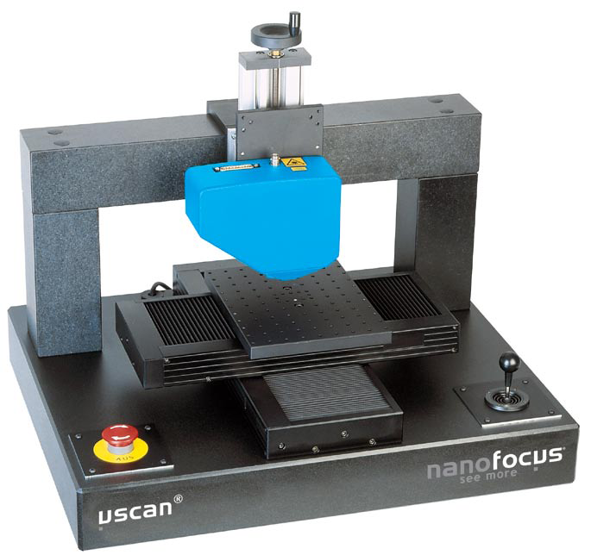
- NanoFocus μScan（激光扫描轮廓仪）
μScan采用模块化设计，特点是快速测量、不接触、不破坏、自动化
μScan的中心部件扫描模块(x/y方向样品扫描)可以和不同的传感器
(Z方向测量)连用，如Confocal point sensor、Autofocus sensor、
Chromatic white light sensor、Holographic sensor等。
AF2 自动对焦（Autofocus)
借由探测器的回馈讯号调整物镜位置，得到待测物焦点，而获得待测物的确实高度（如下左图）。
CF4 共轭焦（Confocal, Laser)
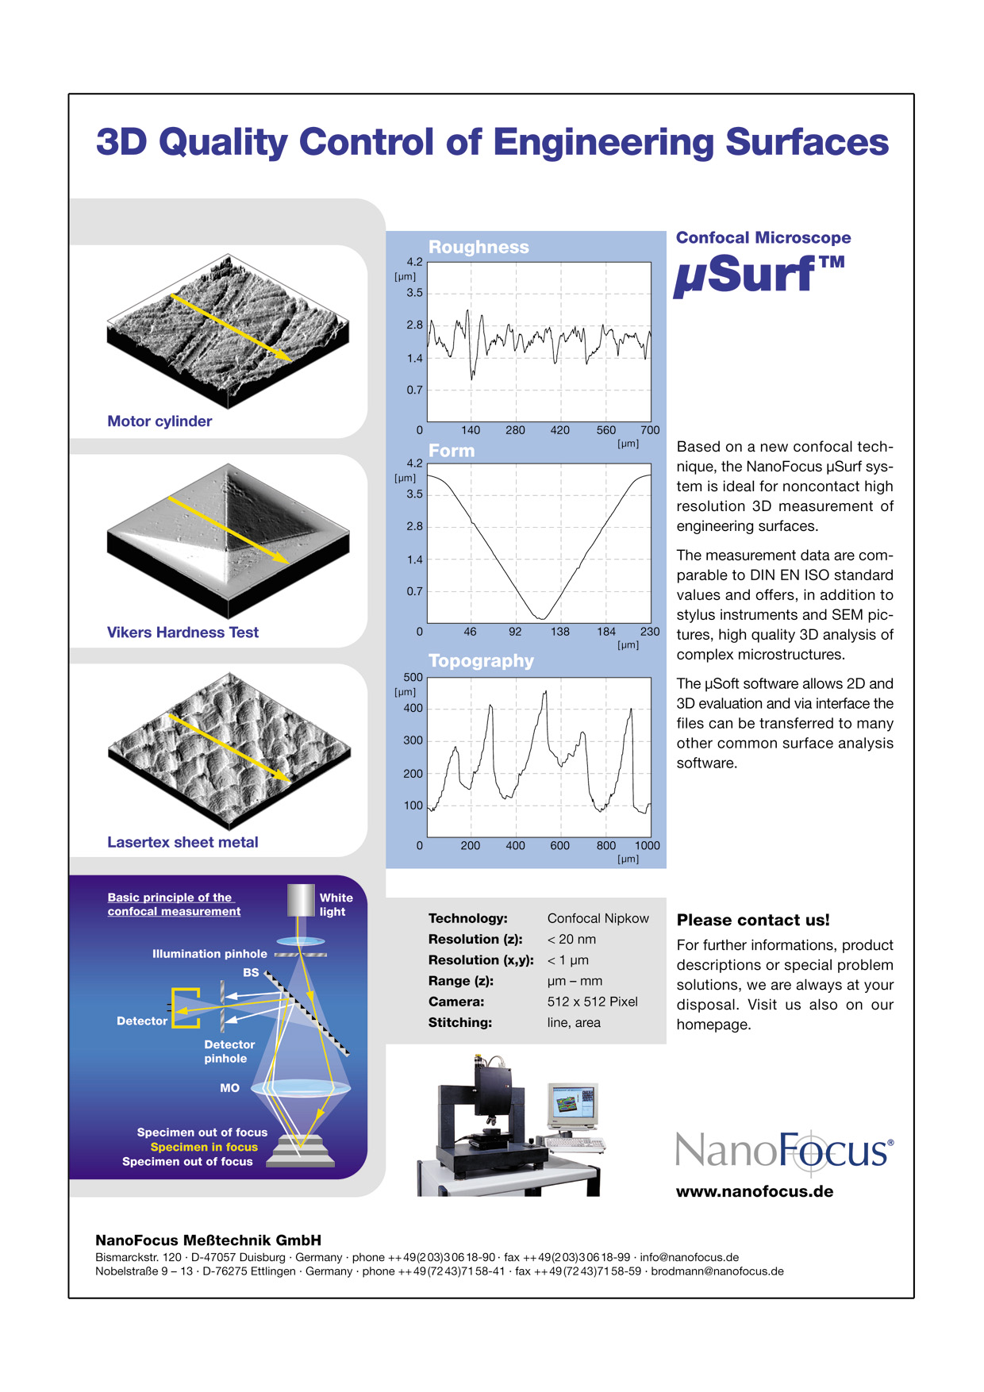
激光光束经由物镜迅速上下移动聚焦于待测物上，此时偵测器能经由孔洞得到最大光的强度，如此侦测器根据此讯号确定其位置（如下右图）。
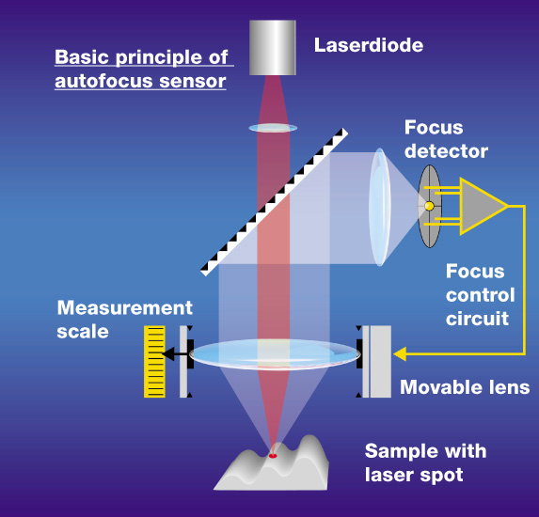
AF2
CF4

- 应用
  - 集成电路封装和表面贴片技术
  - 厚膜混合电路:膜厚度的自动化测量
  - 精密部件
[1] BGA [2] thick film [3] dispenser dots [4] laminate

- 技术参数
Scan modules | Measuring range in x,y-direction [mm] | Resolution in x,y-direction [mm] | Positioning range in z-direction [mm] | Max. measuring speed [mm/s]
SC 50 | 50X50 | 0.5 | 100 | 50
SC 100 | 100x100 | 0.5 | 100 | 50
SC 150 | 150x150 | 0.5 | 100 | 50
SC 200 | 200x200 | 0.5 | 100 | 50
other dimensions on request

Sensors |  | Resolution z [μm] | Resolution x,y [μm] | Working distance [mm] | Measuring range in z-direction [mm] | Camera (optional)
Confocal point sensor | CF 4 | 0.02 | 1 | 4 | 1.0 | off-axis
 | CF 13 | 0.02 | 1 | 13 | 1.0 | (BMT5)
Autofocus sensor | AF 2 | 0.025/0.011¹⁾ | 1 | 2 | 1.5/0.65¹⁾ | integrated
Autofocus sensor | AF 5 | 0.025/0.011¹⁾ | 1 | 5 | 1.5/0.65¹⁾ | (BMT3)
Chromatic white light sensor | CRT 5²⁾ | 0.010 | 4 | 5 | 0.3 | off-axis (BMT5)
Chromatic white light sensor | CRT 12²⁾ | 0.025 | 4 | 12 | 1.0 | off-axis (BMT5)
Chromatic white light sensor | CRT 16²⁾ | 0.075 | 8 | 16 | 3.0 | off-axis (BMT5)
Holographic sensor | CP 15 | 3.0 | 12 | 12 | 1.8 | integrated  (BMT 4)
Holographic sensor | CP 42 | 6.0 | 15 | 42 | 8.0 | integrated  (BMT 4)
Holographic sensor | CP 65 | 10.0 | 25 | 65 | 18.0 | integrated  (BMT 4)
1) with restricted measuring range 2) with 1, 4 or 30 kHz measuring frequency available

Modules
System controller | High performance industrial PC, DVD-Writer, network card,  Windows XP Professional
Cabinet and work table MT 70 | Stable container for electronic modules with work table  1550x800x750 (lxwxh in mm)
Granite measuring stand MP 100 | Portal construction, 660x450x497 (lxwxh in mm) for SC 50 to SC 150
Granite measuring stand MP 200 | Portal construction, 680x480x385 (lxwxh in mm) from SC 200
NF μsoft standard software | NanoFocus control and evaluation software, profile and topography  representation, roughness calculation compliant with DIN EN ISO

Options
NF 3D-Plus | Photo-realistic 3D presentation of topographical data (OpenGL)
NF Active X | Interface modules to program individual measurement processes and  calculations (Excel/VBA)
NF Hybridmaster | Automation tool for the use of μscan® in thick film production incl. SPC and  teach in module
NF Flatmaster | Automated measurement of straightness, flatness and warpage
NF Solder | Automated off-line measurement of fine pitch solderpaste print in SMT production
NF AutoScan | Automated measurement of profiles and surfaces at arbitrary measurement  points

