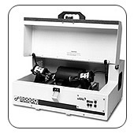
8000D Dual Mixer/Mill
- Efficient two-clamp laboratory mill for pulverizing hard, brittle samples.
- Also called a shaker mill or high-energy ball mill.
- Sample sizes in the 10-gram per vial range.
- Reduces samples to analytical fineness.
- Can be utilized for mechanical alloying.
- Features include a variable-range electronic timer, dual clamps for multiple sample capacity, safety interlock system, and forced-air cooling.
- A European CEE 7/7 two-prong plug is supplied with the 8000D-230 systems.
- One or two samples can be processed simultaneously, however if one sample is processed, a second empty vial must be inserted to maintain the balance of the system.
- Accepts grinding/mixing vials from 2 3/8 in. to 3 1/8 in. in length and up to 2 1/4 in. in diameter.
- The 8010 and 8011 adapters permit processing of multiple samples in 1/2 in. x 1 in., 1/2 in. x 2 in., and 3/4 in. x 2 in. vials.

Specifications
Weight: | 82 lb. [37 kg], 98 lb. (44 kg)
Motor: | 1425 RPM [230 V/50 Hz]
Power Cord: | 2-prong European plug for 230 V/50 Hz version.
Clamp Movement: | 2 1/3 in. back-and-forth, 1 in. side-to-side
Clamp Speed: | 875 [230 V/50 Hz]
Voltage: | 230 V/50 Hz (4 amp fuse)
Controls: | Start, pause, and stop buttons; programmable timer with digital display, factory-set for 100 min. but extendible to 1000 minutes.

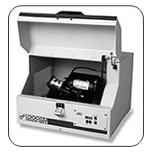
8000M Mixer/Mill®
- Also called a shaker mill or high-energy ball mill.
- Sample sizes in the 10 gram range for grinding and up to 50 ml for mixing.
- Reduces samples to analytical fineness.
- Can be utilized for mechanical alloying.
- Features include a variable-range electronic timer, safety interlock system, and shock-mounted electric motor for tabletop operation.
- A European CEE 7/7 two-prong plug is supplied with the 8000M- 230 systems.
- Accepts grinding/mixing vials from 1^{3/4} in. to 3^{1/8} in. in length and up to 2^{1/4} in. in diameter.
- The 8010 and 8011 adapters permit processing of multiple samples in 1/2 in. x 1 in., 1/2 in. x 2 in., and 3/4 in. x 2 in. vials.

Specifications
Dimensions: | 19 in. (48 cm) x 14 in. (36 cm) x 18 in. (46 cm)
Weight: | 76 lbs. net (35 kg); 92 lbs. gross (41 kg)
Motor: | 1/3 horsepower
Clamp Speed: | 875 [230 V/50 Hz]
Voltage: | 230 V/50 Hz (4 amp fuse)
Controls: | Start, pause, and stop buttons; programmable timer with digital display, factory-set for 100 min. but extendible to 1000 minutes.

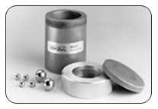
8001 Hardened Steel Vial Set
Vial size 2-1/4 in. diameter x 3 in. Vial body and cap liner of hardened tool steel. Set includes screw-on cap with O-ring to allow wet or dry grinding/mixing, two 1/2 in. and four 1/4 in. steel balls. Grinding load 3–10 ml; mixing load approx. 25 ml.
8001B Steel Ball Set Two 1/2 in. and four 1/4 in. steel balls, for SPEX SamplePrep 8001 and 8009 vials.

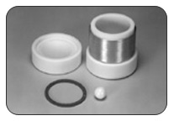
8003 Alumina Ceramic Vial Set
For dry grinding/mixing. Vial size 2-1/4 in. diameter x 2-3/4 in. High purity 99.5% alumina ceramic vial body and two slip-on caps with one 1/2 in. ball; set includes eight corprene gaskets. Grinding load 2–8 ml; mixing load approximately 20 ml.
8003A Alumina Ceramic Ball 1/2 in. diameter for 8003 vial. 8015 Clamp for 8003 Clamps permit slurry grinding in 8003 vial; sold in pairs. One pair required for each 8003.

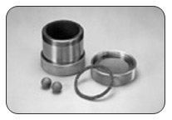
8004 Tungsten Carbide Vial Set
For wet or dry grinding/mixing. Vial size 2-1/4 in. diameter x 2-1/2 in. Tungsten carbide-lined body, two screw-on tungsten-carbide-lined caps, two 7/16 in. tungsten carbide balls, eight corprene gaskets. Grinding load 3–10 ml, mixing load approximately 25 ml.
8004A Tungsten Carbide Ball 7/16 in. diameter for SPEX SamplePrep 5004 and 8004 Tungsten Carbide Vials.

Grinding/Mixing Vial Dimensions
Vial P/N | Description | Overall Height w/Cap & Gasket (mm) | Height w/o Cap (mm) | OD (mm) | ID (mm) | Volume (ml)
3111 | Polystyrene Vial | 27 | 25 | 13.6 | 11.7 | 2.5
3114 | Stainless Steel Vial | 27 | 25 | 12.7 | 11.0 | 2.5
3116 | Polystyrene Vial | 57 | 51 | 13.4 | 10.7 | 5
3117 | Hardened Steel Vial | 27 | 25 | 12.7 | 11.0 | 2.5
3118 | Agate Vial | 43 | 33 | 15.9 | 9.5 | 1.6
3127 | Hardened Steel Vial | 45 | 42 | 14.9 | 12.4 | 5
5004 | Tungsten Carbide Vial | 54 | 48 | 19.0 | 12.5 | 5
6133 | Polystyrene Vial | 54 | 51 | 20.1 | 18.0 | 12
6133 PC | Polycarbonate Vial | 54 | 51 | 20.1 | 18.0 | 12
6134 | Polystyrene Vial | 79 | 76 | 27.9 | 24.9 | 35
6135 | Polystyrene Vial | 78 | 76 | 27.9 | 24.9 | 35
8001 | Hardened Steel Vial | 76 | 64 | 51.1 | 37.8 | 65
8002 | Polystyrene Vial | 72 | 64 | 53.3 | 49.9 | 135
8003 | Alumina Ceramic Vial | 70 | 52 | 51.1 | 37.8 | 45
8004 | Tungsten Carbide Vial | 62 | 50 | 50.7 | 40.6 | 55
8003 | Zirconia Ceramic Vial | 68 | 52 | 57.1 | 38.0 | 45
8006 | Methacrylate Vial | 64 | 60 | 50.9 | 37.9 | 55
8007 | Stainless Steel Vial | 76 | 64 | 50.8 | 37.8 | 65
8008 | Silicon Nitride Vial | 62 | 52 | 57.2 | 37.5 | 45
8009 | Round-End-Hardened Steel Vial | 76 | 42 | 58.8 | 37.9 | 35
8014 | Agate Vial | 70 | 53 | 46.9 | 35.3 | 40

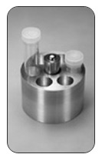
8010 Multiple-Sample Adapter
Holds seven vials, each 1/2 in. in diameter, for simultaneous running in 8000M Mixer/Mill. Suitable vials include SPEX SamplePrep 3111, 3114, 3116 and 3117. Vials run at one time should be same length. Can be used in 8000D Mixer/Mill with 3116 vials, or with 3111, 3114, and 3117 vials if 8012 adapter is also used.

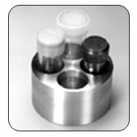
8011 Multiple-Sample Adapter.
Holds four vials, each 3/4 in. in diameter, for simultaneous running in 8000M Mixer/Mill. Suitable vials include SPEX SamplePrep 3118, 3127, 5004 and 6133. Vials run at one time should be same length. Can be used in 8000D Mixer/Mill with 3118, 5004, and 6133 vials. To use 3127 vials in 8000D, 8012 adapter is also necessary.

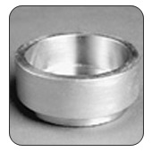
8012 Vial Clamp Adapter for the 8000D Mixer/Mill
Required when running 8010 adapter with 1 in. vials (3111, 3114, 3117) or 8011 adapter with 3127 vials in the 8000D.

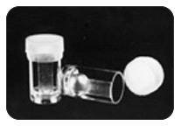
3111 Polystyrene Vial
1/2 in. diameter x 1 in. long. Includes slip-on polyethylene cap. Capacity 2.5 ml; mixing load approx. 1 ml; accepts SPEX SamplePrep 3112 or 3119 plastic balls. Sold in units of 100.

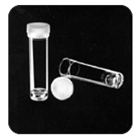
3116 Polystyrene Vial
1/2 in. diameter x 2 in. long. Includes slip-on polyethylene cap. Capacity 5 ml; mixing load approx. 2 ml; accepts SPEX SamplePrep 3112 or 3119 plastic balls. Sold in units of 100.
3116PC Polycarbonate Vial
1/2 in. diameter x 2 in. long. Includes slip-on polyethylene cap. Capacity 5 ml; mixing load approx. 2 ml; accepts SPEX SamplePrep 3112 or 3119 plastic balls. Sold in units of 100.

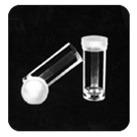
6133 Polystyrene Vial
3/4 in. diameter x 2 in. long. Includes slip-on polyethylene cap. Capacity 12 ml; mixing load approx. 5 ml; accepts SPEX SamplePrep 3112 or 3119 plastic balls. Sold in units of 100.
6133PC Polycarbonate Vial
3/4 in. diameter x 2 in. long. Includes slip-on polyethylene cap. Capacity 12 ml; mixing load approx. 5 ml. Sold in units of 100. Accepts SPEX SamplePrep 3112, 3119, and 8006A plastic balls.

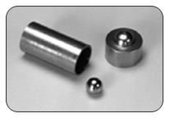
3114 Stainless Steel Vial Set
1/2 in. diameter x 1 in. long. Made of 303 stainless steel; includes slip-on cap and 1/4 in. stainless steel ball; grinding load 0.2–0.6 ml, mixing load 1 ml.

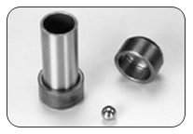
3127 Hardened Tool Steel Vial Set
3/4 in. diameter x 1 ^{7/8} in. long. Made of Worpliss tool steel; includes center cylinder with two slip-on caps and 1/4 in. steel ball. Grinding load 0.5–1.0 ml, mixing load 2 ml.

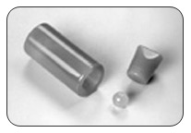
3118 Agate Vial Set
Handmade from flawless Brazilian agate; must be run inside cushioned SPEX SamplePrep 6133 vial (included). Includes stopper and 1/4 in. agate ball (3118A) Grinding load 0.2 – 0.6 ml, mixing load 1 ml.

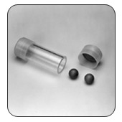
5004 Tungsten Carbide-Lined Vial Set
3/4 in. diameter x 2 ^{1/8} in. long. Includes two slip-on Delrin® caps with tungsten carbide inserts, six disposable methacrylate center cylinders, and two 5/16 in. tungsten carbide balls(5004A). Grinding load 0.5–1.5 ml; mixing load 3 ml.
窗体底部
窗体底部

