microflex
microflex™LT
高性能台式MALDI TOF飞行时间质谱仪
产品描述

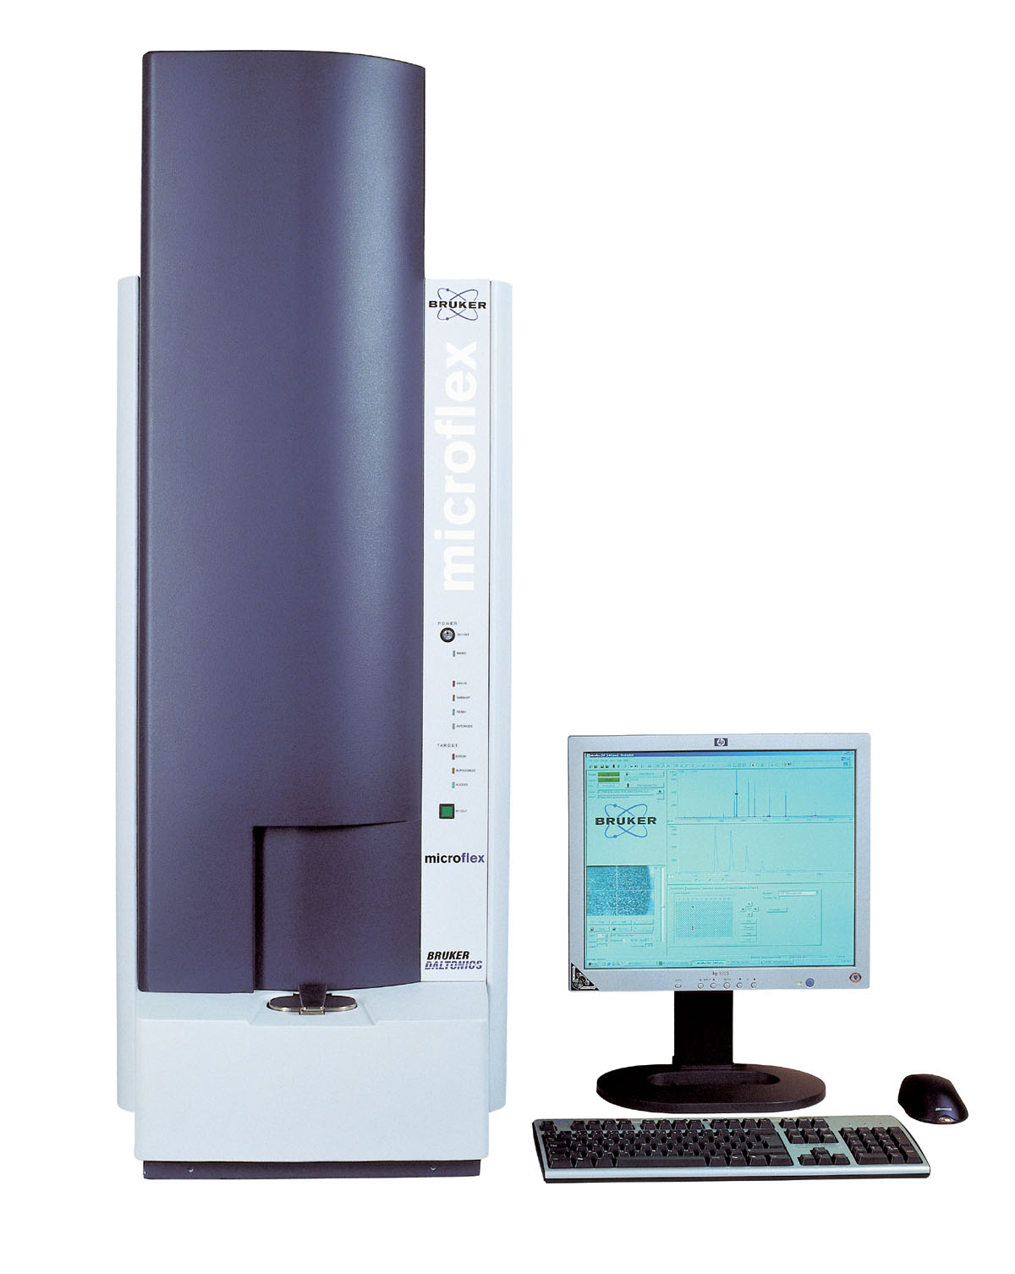
Appendix to quote number:

microflex™LT
A powerful benchtop Time-of-Flight Mass Spectrometer
equipped with MALDI Ion Source, exclusively for linear mode
强大的台式飞行时间质谱仪，
配有MALDI离子源，专为线性模式操作

Part # | Description 描述
600302 | microflex™LT MALDI-TOF Benchtop System  Small footprint, silently operating MALDI-TOF mass spectrometer with industrial hardened vertical design including self diagnostics of major components.  占地面积小、操作安静、垂直式工业化设计且对主要部件具有自我诊断功能的MALDI-TOF质谱仪  A. Time-of-flight Mass Spectrometer with following configuration: 飞行时间质谱具有以下配置：  - Linear TOF analyzer for both positive and negative ions  线性TOF质量分析器，具有正、负离子检测模式  - Saturation free detector technology for highest dynamic range, superior performance for high mass detection  非饱和型检测器技术，具有最宽的动态范围和优越的高端质量检测性能  - 60 Hz N2-Cartridge-Laser including variable power attenuator and UV optics  60 Hz 盒式氮气激光器，激光强度、频率均可调以及优化的激光光路系统。  - microScout™ ion source; Medium area target (54mm x 36mm) with exact dimensions of 1/4 microtiter plate  microScout™离子源；中等面积样品盘(54mm x 36mm)采用1/4工业标准的微滴定盘设计  - Ion source with proprietary panoramic PAN™ pulsed ion extraction for highest resolution across an extended mass range  离子源采用布鲁克专利的全景式宽域离子聚焦 (PAN™)技术和脉冲离子提取 (PIE™)技术相结合，在很宽的质量范围内同时达到高分辨率。  - microScout™ Target Kit including: two MSP96 ground steel targets (#224990), one target each of MSP96 polished steel (#224989), MSP AnchorChip 600/96 (#224988), NALDI targets (5 plates) (#252248) and a MSP NALDI adapter (# 249320)  microScout™标配样品靶包装包括：两块MSP96不锈钢非抛光靶板(#224990)，一块MSP96不锈钢抛光靶板(#224989)，一块MSP AnchorChip 600/96靶板(#224988)，5块NALDI靶板(#252248) 和一个MSP NALDI 靶托 (# 249320)  - Manually operated probe inlet  人工操作的离子源进出杆  - Simple mouse controlled precise X-Y target positioning  精确的X-Y位置，可由鼠标简单控制  - High resolution magnifying target observation optics with integrated display in Compass™ acquisition software  高分辨样品靶板放大监视系统，整合于Compass™仪器控制软件  - Ultra-stable power supplies for TOF analyzer, detector and ion source  TOF质量分析器、检测器和离子源均配有超稳定电压控制  - Integrated pumping system including vacuum measurement and control unit: 70 l/sec turbo-molecular pump including diaphragm-pump  整合的真空测试与监控系统：一个转速为70 L/sec的分子涡旋泵和一个隔膜泵  B. Data System and Software 数据系统和软件  - HP Workstation / Windows™ XP operating system, ≥ 2.4 GHz Single-CPU-Dual-Core-processor, 3 GByte RAM, 500 GByte hard disk, DVD +/-RW drive 16x DL LightScribe, DVD-ROM drive, 1x Ethernet connection for external networks, 500 MHz Digitizer plug-in card; ≥ 20” HP LCD-Display  HP 工作站/Windows™ XP操作系统, 2.4 GHz的单CPU双核处理器，3 GByte内存，500 GByte硬盘，DVD +/-RW drive 16x DL LightScribe, DVD-ROM drive，一个外网连接口，500 MHz数字转换卡，≥ 20” HP LCD显示屏  - Laser printer 激光打印机  - Mass spectrometry software Compass™ 1.2 for Flex: Software package for MS data acquisition and processing including one licence each of flexControl and flexAnalysis, AutoXecute™ with fuzzy-logic optimization for automated acquisition  Flex Compass™ 1.2软件包：用于质谱数据采集的控制软件flexControl及软件授权号，flexControl软件包括AutoXecute™智能化数据自动采集模块；质谱数据处理软件flexAnalysis及软件授权号  - Remote Service capability via 128-bit SSL-security web connection  基于128位 SSL安全网页连接的远程诊断功能  C. Miscellaneous 其它  - Installation; Familiarization upon installation  免费安装；安装工程师对用户进行基本的熟悉仪器培训  - year warranty  一年保修

