WSeen’s HiCC-B1 automatic colony counter
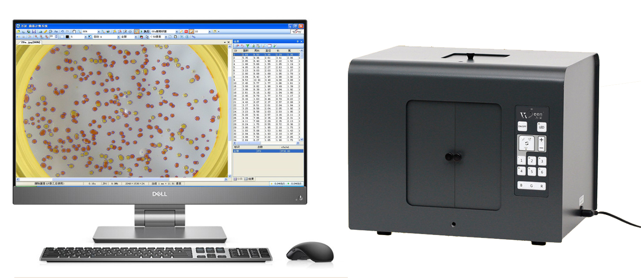
Overview:
WSeen’s HiCC-B1 automatic colonies counter from the PC, automatic colony counting software, backlight imaging device. Mainly used for micro-organisms, the total count of the automatic count analysis, rapid and effective alternative to manual or semi-automatic counting of colony lagging work.

Features:
1, by a PC, the software will automatically count and output the number of colonies.
2, by adding, deleting the individual pointing correction, can make a few grains up to 100% accuracy.
3, can view the results table, export to EXCEL, and to the designated recipient to upload data.
4, highlight LED backlight device to colony count recognition more stable, can work long hours.
5, Windows system environment, user-friendly, concise, intelligent.

Technical Parameters:
1, with a color 800 megapixel autofocus camera, the highest resolution of 0.05mm, can identify as small as 0.1mm colony
2, suspended dark field of vision, the backlight can be switched imaging analysis of ultra-thin imaging device
3, to adapt Petri dishes diameter: 50 ~140mm plate (pouring, membrane filtration, 3M paper)
4, automatic segmentation of chain or lumps of various types of colonies adhesion
5, automatic counting accuracy ≥ 96.5%, with very few amendments up to 100% correct. Analysis speed: 50 - 300 colonies / s
5, automatic removal of impurities, click on the touch screen correction, effective support for complex microbiological statistics
6, can save tens of thousands of pictures and their corresponding data, and wireless Internet to send pictures remotely, the result data

Availability list: a LED imaging device with 800 megapixel color camera and a power adapter (for AC220V), a software lock (under windows 10 Professional edition) and a software U disk, a dark field of a black film

