The Real Time Strain Sensor (RTSS) Software

The RTSS Software is used for the contact less strain analysis system based on a single camera and real time image processing. It’s main purpose is to measure online the strain between two line markers during tensile testing.

Typical applications are:

- Determination of material properties like Young’s modulus, Poisson’s ration
- Strain controlled tensile tests
- Cyclic, dynamic and high-speed tests
- Vibration analysis, etc.
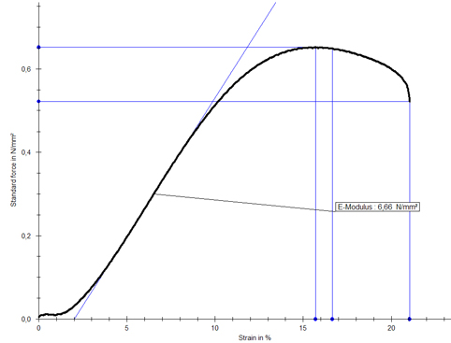
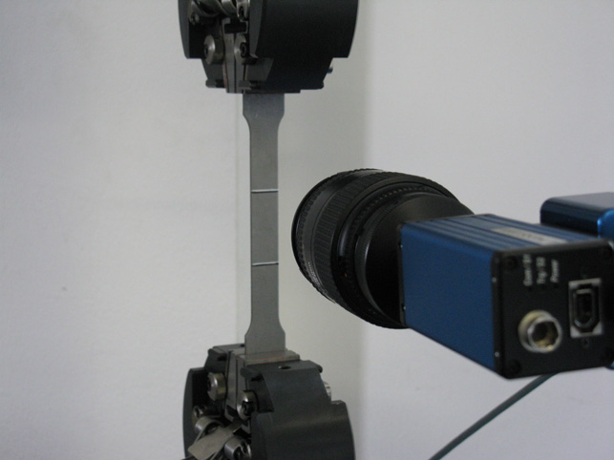

The measurement data is transferred via digital or analog interface to the tensile test machine, external devices or control software. RTSS is compatible to most universal tensile test machines like Instron, MTS, Zwick, Schenk, etc.
Features:
- Video-extensometer for tensile test machines.
- Measurement rates of typically 70Hz (Other measurement rates on request)
- Measurement of:
  - Longitudinal strain via 2 line markers.
  - Distance [mm] of the line markers and point markers
  - Transversal strain from specimen geometry and point markers
  - Width [mm] of the specimen
  - Necking
  - Elongation at break
- Multi marker tracking: For a spatial resolved strain measurement up to 20 line markers can be measured simultaneously.
- Measurement precision 0.002% for longitudinal strain (HR version)
Measurement precision Class 1 for distance measurement (HR version)
- Single images (TIF, BMP, JPG) can be saved during the test. The images can be converted to AVI movies and the strain distribution can be analyzed afterwards with digital image correlation.
- Available data interfaces:
  - Serial interface
  - Log file: ASCII/CSV
  - Optional: Analog (2 channels, ±10V, 16bit) with DAQ hardware
  - Optional: DOLI-Controller-compatible
- A modern, configurable and intuitive user interface
- Usage of templates for different test setups and applications
- The multi-thread analysis kernel support multi-core processors to achieve a low processor load. (The RTSS software can be used on the control computer oft the tensile test machine.)
- Scope of delivery: Software license, Installation CD and manual
- Multilingual user interface (German, English, more on request)

Multi-camera module: Multiple cameras can be connected to one computer and be used in the following modes:
- Independent mode: Measurement of front and back side of specimen.
à Consideration of the deflection of a tensile specimen.
- Dependent mode: à Combination of the precise Youngs modulus measurement (small FOV camera) and the complete measurement of the stress-strain curve (with large FOV camera).
- Stereo mode: The two cameras are mounted at a defined distance. Each camera measures with a high precision due to its small FOV.
à High precision strain measurement at stiff material up to about 10% of strain.

The calibration delivers measurements in mm.

