

Field NDT inspections with Shearography



**NDT inspection on a honey- comb aerospace part.**

Digital Shearography NDT System Q-810

# Applications

* In-field use for large area NDT inspections
* Detection of delaminations, disbonds, kissing bonds, wrinkling impact damage, crushed core and much more
* Defect detection in composite materials carbon fiber, glass fiber, laminates, honeycomb etc.

# Features

* A certified NDT method, ASNT, EN 4179, NAS 410 and ASME
* Rapid full-field inspection rate 300 mm x 200 mm

every 10 seconds

* Adaptive seals for use on highly curved surfaces
* Operates independent of the local environmental conditions and can be used for production or in-field inspections
* Simple 2 button operation



# **Wrinkles, Dry-spots, Bond-lines…**

The Q-810 System can detect defects including wrinkles, dry-spots, delaminations, disbonds, impact damage and many more with no surface preparation. It can also be used to investigate structural integrity, bond-lines and the separation of structural components. The turn-key optical system is non-contact and full-field and will work on such materials as glass fiber and carbon fiber laminates.

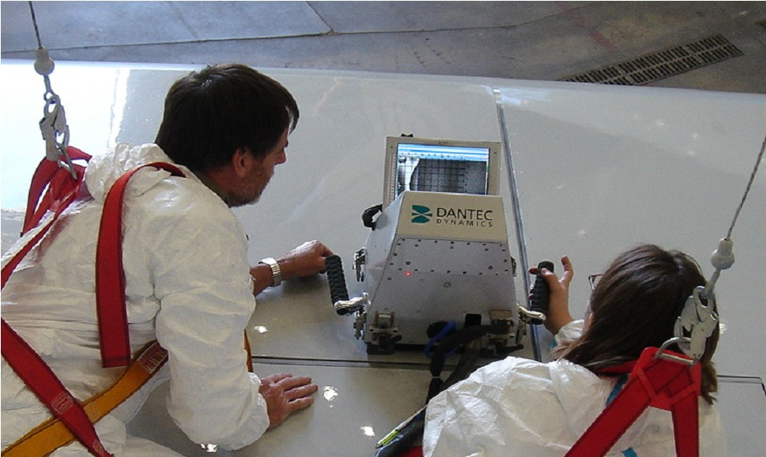

# **Large Surface Area Coverage**

The integrated systems are optimised for large surface area inspections, for example on aircraft fuselages, wings,



control surfaces, ship hulls, wind turbine blades and rocket components. The full-field inspection rate is a rap- id 300 mm x 200 mm every 10 seconds. With adaptive seals the systems can be used on flat as well as highly curved surfaces.



# **A Certified Technique**

Shearography has been incorporated in ASNT standards since 2006. NAS 410 Certified since 2008. (SNT-TC1-A, and CP-105). ASTM standard (ASTM E2581) defines how to inspect composites with shearography. Laser shea- rography has been approved by leading suppliers in

the aerospace, automotive, wind turbine and other industries.

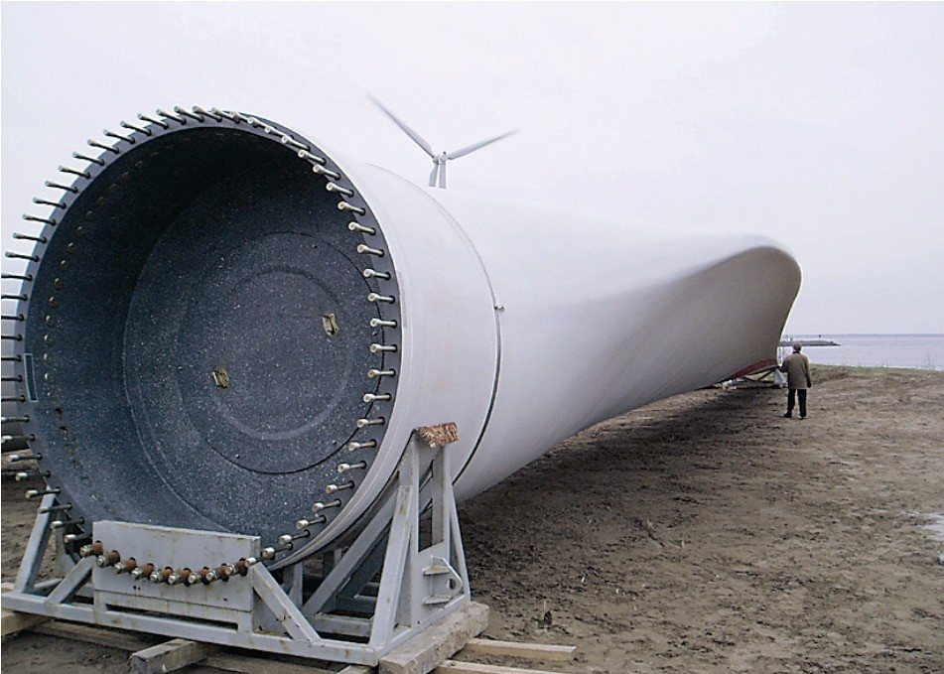

*Rotor blade NDT inspections with Shearography*

# **Additional information**

For additional information please contact your Dantec Dynamics representative.

Flyer 384_v1. Subject to change without notice. Copyright © 2016 Dantec Dynamics. All Rights Reserved.



[www.dantecdynamics.com](http://www.dantecdynamics.com/) 