2020 YX-007-SK Air Purifier Type Recording jammer

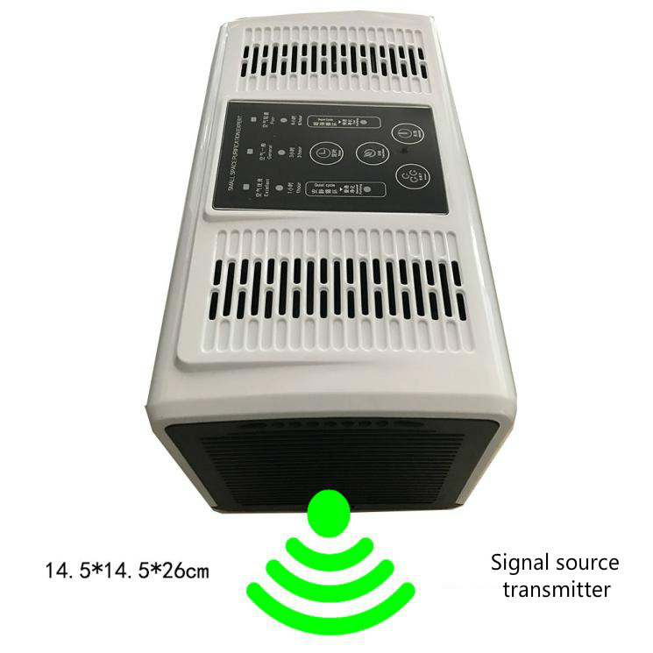
This recording jammer is a new product in the Heroley recording jammer. It integrates the functions of air purification and recording jammer. The recording jammer and air purification control do not affect each other.

Air purification is controlled by keys on the host computer. The recording jammer is equipped with a separate remote control, which opens and closes, and protects its information security without any detection.

Scope of application: Office, conference room, secret room and other places where recording is not allowed.

Section 2020 Upgrade:
1: jammering distance has been greatly increased to 2-5 meters;
2: Increased power stepless adjusting knob to adjust power flexibly;
3: Software and signal transmitting terminals are replaced comprehensively with better performance;

Product Advantage:
Good concealment：The air purifier is used as the appearance of the product. On the surface, it is the same as the ordinary air purifier. At the same time, the background noise is increased and the concealment is very strong.

jammering effect is stronger：Compared with other products in the series, the output interference signal power is larger, so the noise signal picked up by the recording equipment is stronger, and the jammering effect is stronger.

jammering distance is farther：Compared with other products, the jammering distance is farther. Generally speaking, the jammering distance of better recording equipment can reach 2-5 meters, covering a wider range of equipment. For the current mainstream recording equipment, the air purifier version of the recording jammer can jammer, and its coverage rate can reach more than 95%, far higher than the same kind on the market.

Be careful：Due to the variety of recording equipment, the product can not test all recording equipment, so it can not promise 100% (please understand),Mainstream recording devices such as iphone, HUAWEI phone, MI phone, oppo phone, vivo phone have been tested.

technical parameter：
project | performance parameter
Types of jammering equipment | Mobile phones, digital recording pens, recorders and other sound acquisition equipment
jammering radius | 2-5 meters
Angle of action | 90-120 degrees
Remote control distance | More than 10 meters
Product size | 260*145*145 mm
weight | 1.5 kg
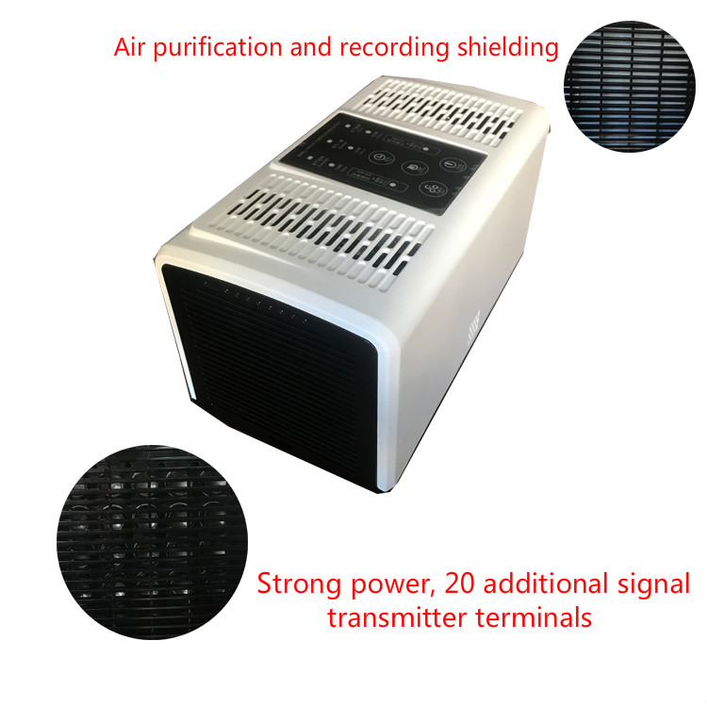

Particular attention：
The shape of the product is well concealed, and it can be closer to the people who may record, and the effect is better!

