产品使用说明书

Product Instruction

产品型号：YX-007-FX(X=4/6/8/12)

Product Model: YX-007-FX(X=4/6/8/12)

天津市英讯科技有限公司

目录

Contents

一、认识设备Introduction of Equipment 3
1. 设备部件清单List of Product 3
2.设备部件介绍.Introduction of Equipment Units 5
二、 使用说明Instructions 6
三、 技术参数Technical Parameters 15
四、 安全注意事项Safety Cautions 16
五、 温馨提示Warm Warning 17
六、 演示视频地址Website of Demo Video 17
保修卡 18

一、认识设备Introduction of Equipment

设备部件清单List of Product
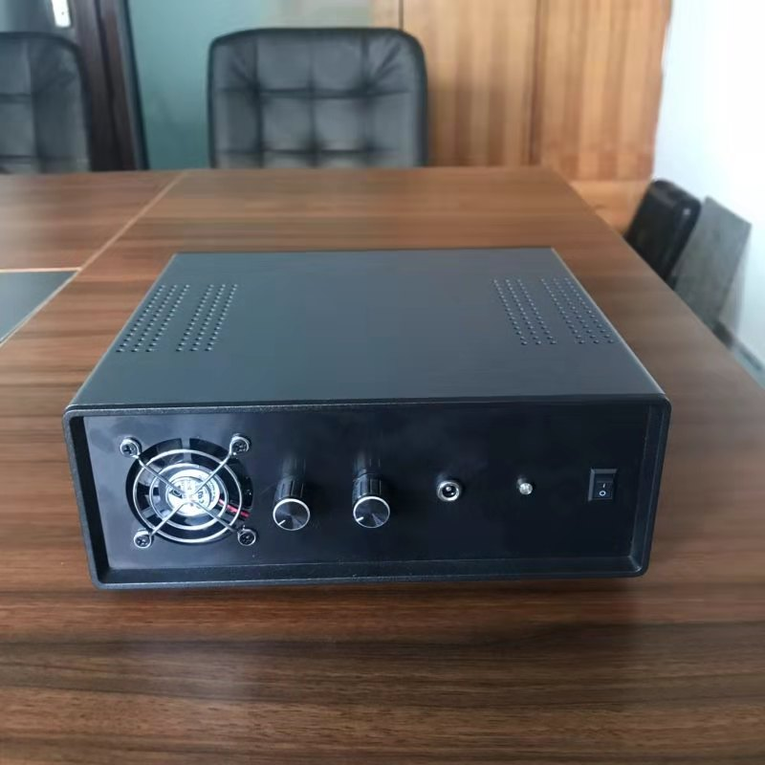
YX-007-FX(X=4/6/8/12)主机1台

扩展器X(X=2/4/6/8/12)

遥控器1个

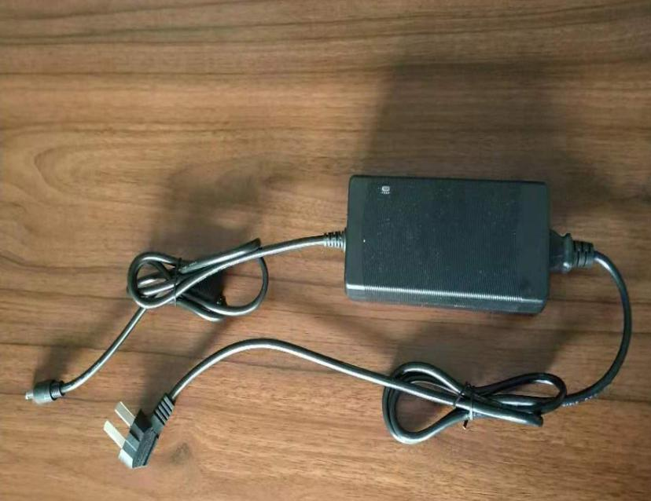
电源适配器1个

连接线X(X=2/4/6/8/12)根

2.设备部件介绍.Introduction of Equipment Units
FY-007-X(X=4/6/8/12)主机
FY-007-X (X = 4/6/8/12) host
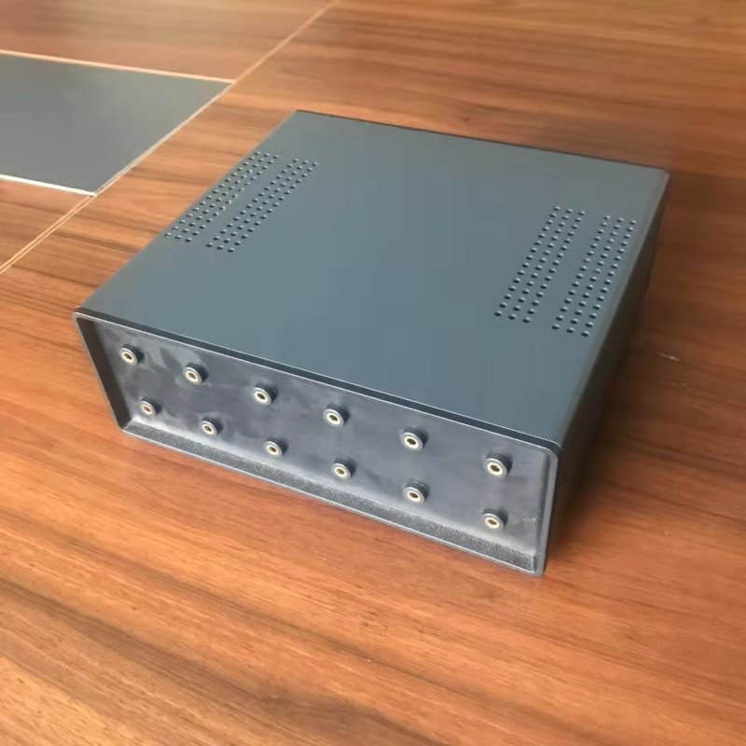
主机上的扩展器插口
Extender socket on host
扩展器 Expander
扩展器前端的信号发射端子
Signal Transmitting Terminal of Expander Front End

扩展器后端的音频线插口
Audio line socket at back end of expander

使用说明Instructions

设备部件连接 Equipment connection and boot-up
- 把主机与扩展器连接，接线方法如下图
Connect the host to the extender. The wiring method is as follows
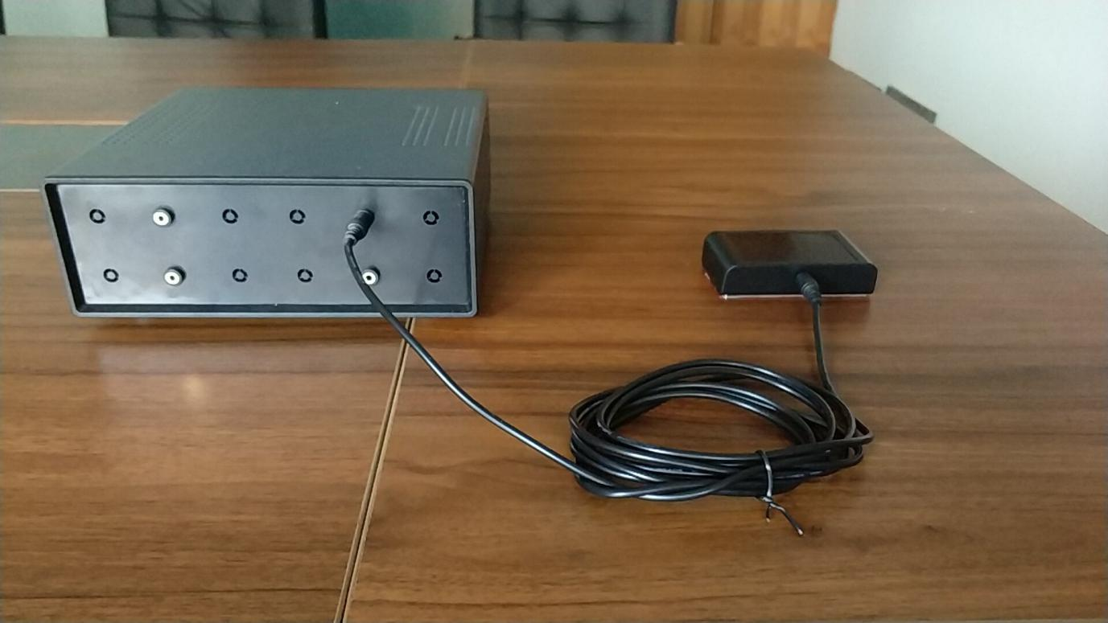
主机与扩展器用连接线连接
Connecting Host with Extender
其它扩展器也如上图接线方法连接
Other extenders are also connected as shown in the wiring method above.

- 适配器与主机，适配器与电源连接图，接线方法如下图
Connection diagram between adapter and host, adapter and power supply. Connection method is as follows
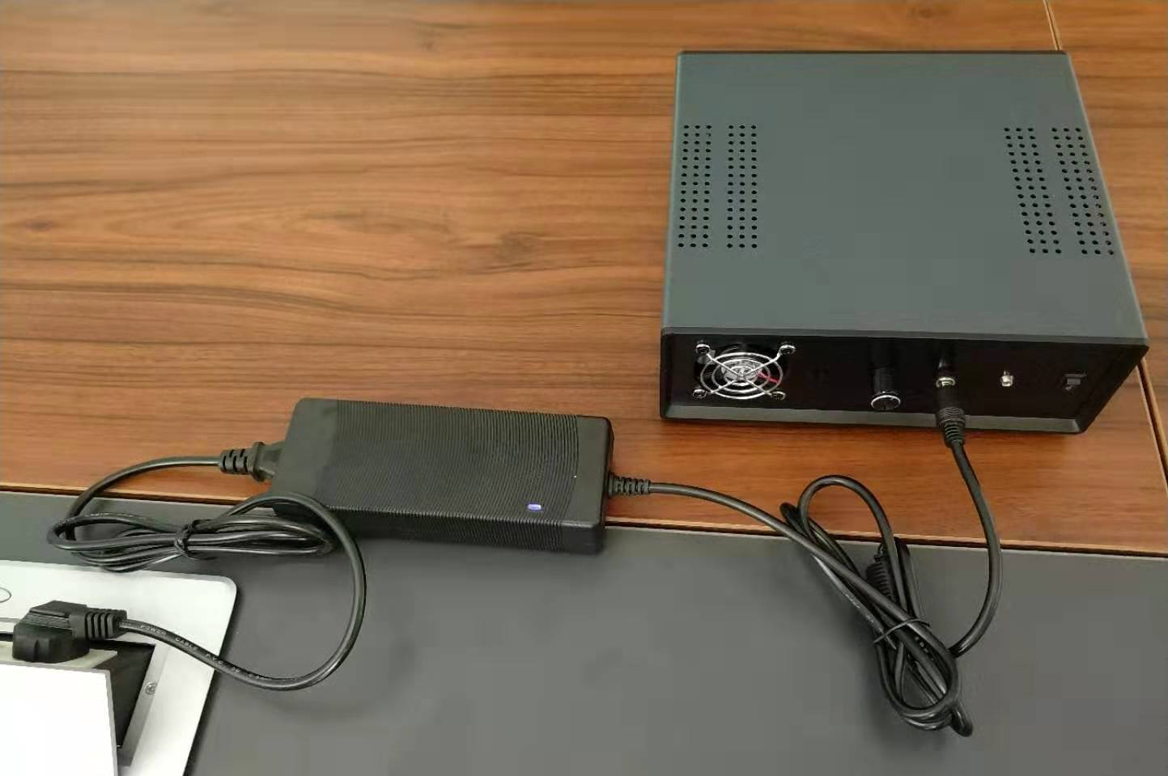
适配器与主机，适配器与电源连接图
Connecting Host with Extender

设备现场布置安装范例Installation Example of Equipment Field Layout
- 先安装扩展器，安装方法及位置如下图
Firstly, install the expander. The installation method and location are as follows.

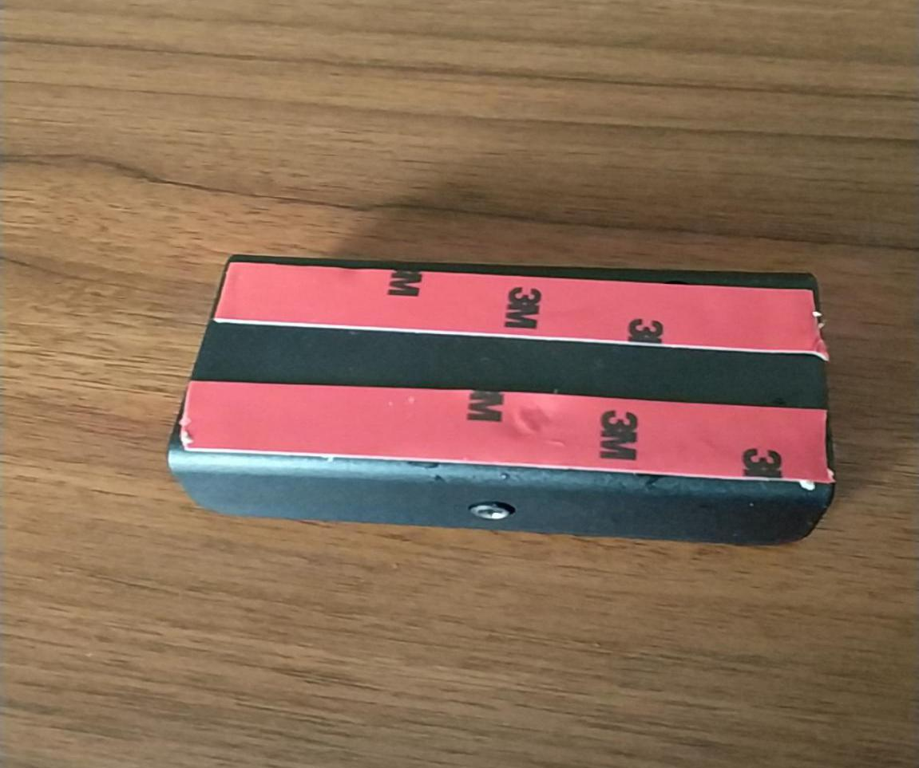
安装扩展器前先将扩展器的底部用双面胶粘好
Glue the bottom of the expander with double-sided glue before installing the expander

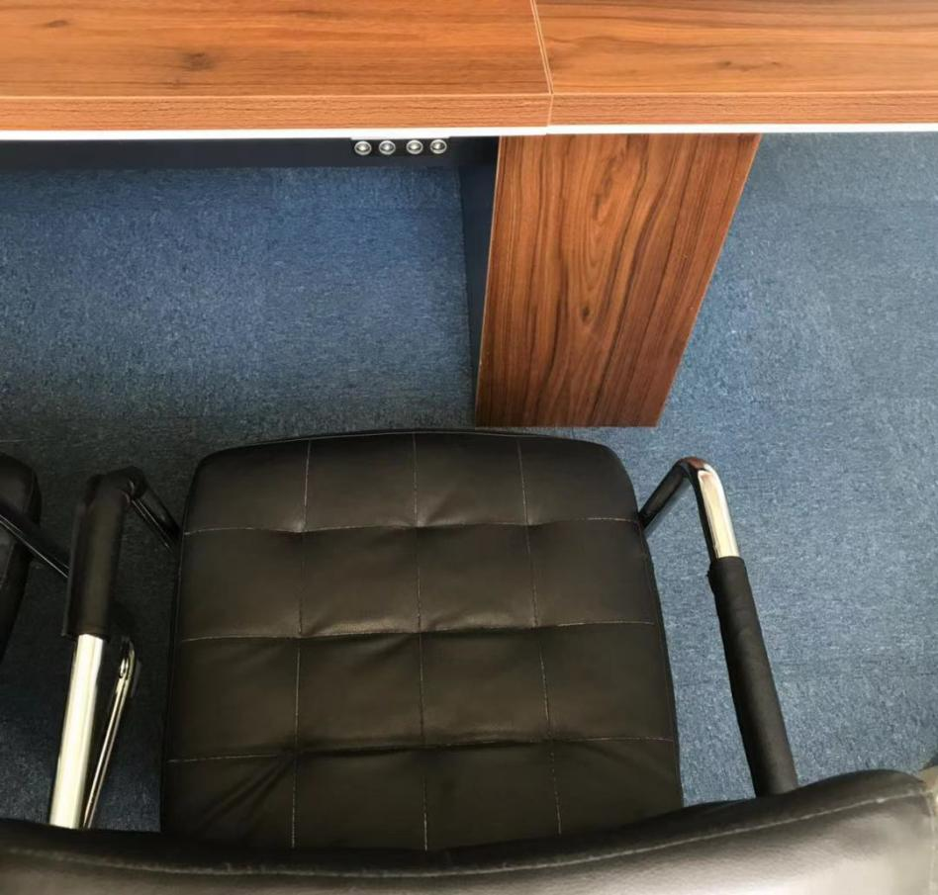
扩展器贴于桌子边缘下方正对座位
The expander is attached to the seat directly under the edge of the table.

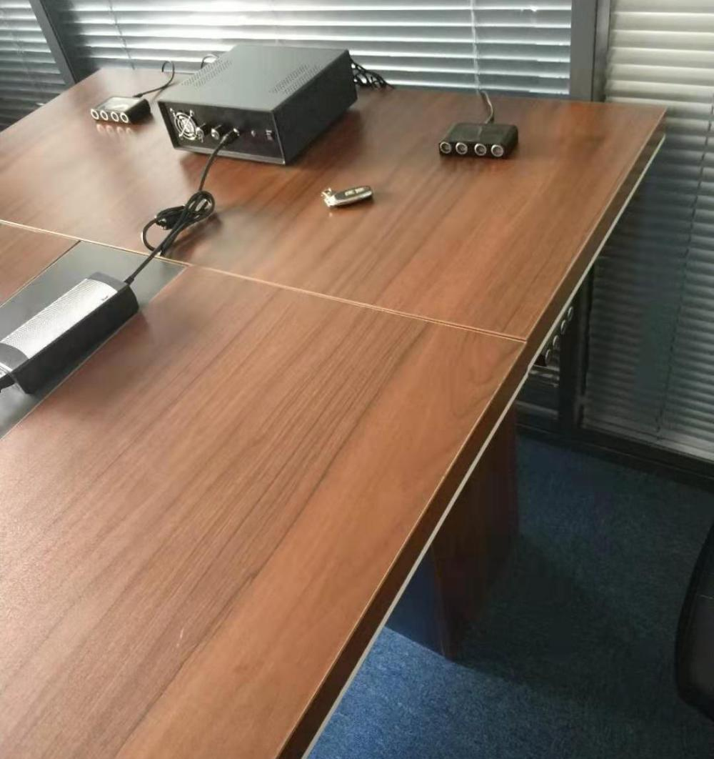
根据不同的使用环境，在桌子上面也应布置扩展器
Expanders should also be placed on tables according to different usage environments.
设备主机根据不同使用环境可任意布置
The main machine of the equipment can be arranged arbitrarily according to the different use environment.

注：更多现场布置方法请咨询经销商

使用方法Usage method
- 打开主机电源开关，电源指示灯亮起，设备进入待机状态（参考图1）
Turn on the power switch of the main engine, the power indicator lights up, and the equipment enters standby state (refer to Fig. 1).

- 按遥控器开机键设备开始工作（参考图2）
Press the remote control boot button to start the device (refer to Fig. 2)

- 调节功率（参考图3、4、5）
Power adjusting knob (refer to figs. 3, 4, 5)

调节功率旋钮已达到最佳的屏蔽效果（旋钮顺时针旋转功率变大，逆时针旋转功率变小）
The power adjusting knob has achieved the best shielding effect (the knob rotates clockwise with greater power and counterclockwise with less power).

- 关闭设备,先关遥控器，再关主机电源
Turn off the equipment, turn off the remote control first, then turn off the power supply of the main engine.

向上拨主机通电
Dial up the main engine to power on向下拨主机断电
Down-dial mainframe power off
通电后亮蓝灯
Turn on the blue light after electrification
断电灭灯
Turn off the lights and turn off the lights.
图1
Figure 1
YX-007-FX(X=4/6/8/12)主机通电后通过遥控器控制设备启动停止
YX-007-FX (X=4/6/8/12) The main engine is powered on and the device is controlled by remote control to start and stop.
遥控器开机键
Remote control boot key
遥控器关机键
Remote control shutdown key
图2
Figure 2

功率调节旋钮B
Power adjustable knob B

YX-007-FX(X=8/12)主机箱
YX-007-FX (X=8/12) Host Box
功率调节旋钮A
Power adjustable knob A

图3
Figure 3

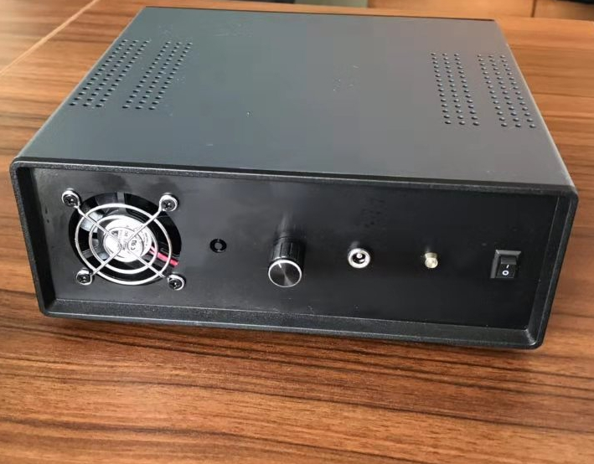
YX-007-FX(X=4/6)主机箱
YX-007-FX(X=4/6）主机箱
功率调节旋钮控制所有扩展器输出功率

YX-007-FX (X=4/6) Host Box
Power regulation knob controls the output power of all expanders
图4
Figure 4

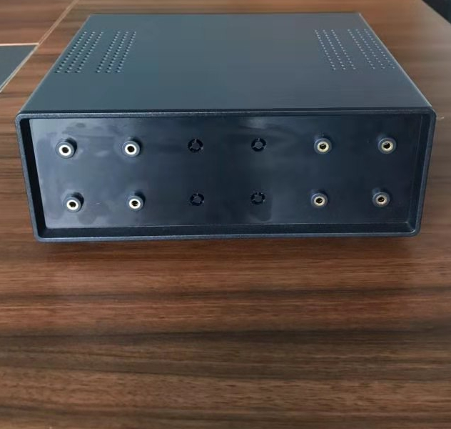
A区
YX-007-FX(X=8/12)主机箱
功率旋钮A 控制A区的扩展器输出功率
功率旋钮B 控制B区的扩展器输出功率

B区
YX-007-FX (X=8/12) Host Box
Power Knob A Controls the Output Power of Expander in Area A
Power Knob B Controls Output Power of Expander in Area B

图5
Figure 5

特别注意：
严禁机器工作中物理插拔扩展器，应用使用遥控关机后插拔，再用遥控器开机。

Special attention should be paid to:
It is strictly forbidden to use physical plug-in expander in machine work. Use remote control to shut down and plug-in, then use remote control to start.

开机后根据使用场景调整扩展器的位置和角度固定，扩展器作用区域不要有障碍物阻挡，扩展器的摆放原则参考下图及视频

After startup, the position and angle of the expander are fixed according to the usage scenario. There are no obstacles in the expander's working area. The principle of the expander's placement refers to the following pictures and videos.

https://detail.1688.com/offer/588586106810.html?spm=a2615.7691456.autotrace-offerGeneral.10.58182901mdkQbR

扩展器放置完毕，用录音设备测试，并调节功率旋钮，以达到最佳屏蔽效果为宜。
When the expander is placed, it is appropriate to test with recording equipment and adjust the power knob to achieve the best shielding effect.

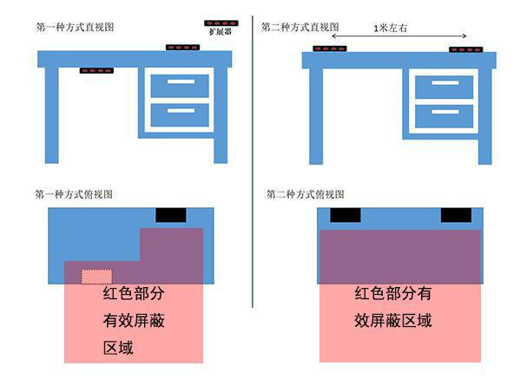

特别注意：如果本款录音屏蔽系统对个别录音设备屏蔽效果不理想，建议采用两套即可解决！

应用场合Applications

本款YX-007-FX(X=4/6/8/12) 录音屏蔽器是由天津市英讯科技有限公司自主研发的，高度集成化的高科技安全防护产品。当不法分子采用录音设备（如手机、录音笔、录音机等）对您进行录音时，录音屏蔽器会产生随机性的噪音信号，该信号能够对语音信号产生压制性干扰，使录音设备拾取的只有噪声信息，而无法分辨出语音信息，从而确保语音信息的安全。广泛应用于：领导办公室、保密会议室、军事作战室、商务谈判室等一切防止录音的场所。

This YX-007-FX(X=4/6/8/12) recording shield independently researched and developed by Tianjin Yingxun Technology Ltd, is a high-tech safety protective apparatus with high level of integration. In case of being illegally recorded via recording devices (such as mobile phones, recording pens and recorders and so on), the recording shield will generate random noise signals which can oppressively interfere with speech signals so that only noise information is picked up by recording devices and the speech information cannot be distinguished to make sure of safety of speech information. Generally applied: head office, confidential meeting room, military operation room, business negotiation room and any other places which need to be protected from being recorded.

测试及注意事项Testing and precautions
此产品采用射频信号屏蔽录音设备，因此开启后有稍许声响属于正常，根据年龄对声响的反应有差异，此声响对人体没有任何影响。
This product uses radio frequency signal shielding recording equipment, so a little sound after opening is normal, according to the age of the response to sound is different, this sound has no impact on the human body.

测试时要模拟真实的使用环境，用正常的音量沟通即可，不必故意提高音量，此产品兼顾本身噪声和实际的屏蔽距离采用最佳软件版本，如有特殊需求可以向我们所要特殊版本的软
件！
When testing, it is necessary to simulate the real environment and communicate with normal volume without intentionally increasing the volume. This product takes into account its own noise and actual shielding distance and adopts the best software version. If there are special requirements, it can give us the special version of the software we need！

注意：桌面型录音屏蔽器的发射端子正对录音设备的时候屏蔽效果最好。

Notes: there will be best effect of shielding when emission terminals of desktop

recording shield are directly facing recording devices.

产品型号对照图Product Type Control Chart
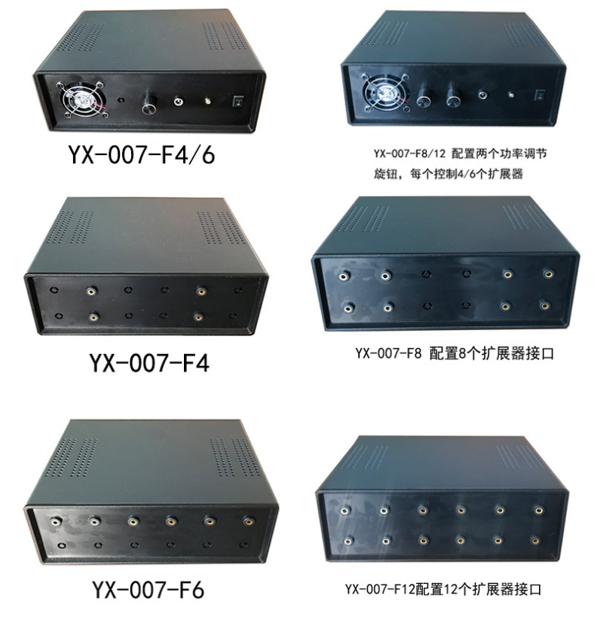
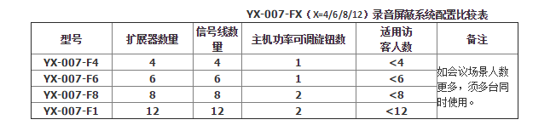

技术参数Technical Parameters
项目 | 性能参数
屏蔽设备类型 | 手机、数码录音笔、录音机一切声音采集的设备
屏蔽效果 | 83%以上
屏蔽距离 | 1-2m
屏蔽角度 | 90-120 度
重量 | 1.3kg
产品尺寸 | 220*195*80mm
供电模式 | 内置电池/适配器
工作电流 | 2.2A
干扰模式 | 声学干扰
干扰强度 |  | 85dB
工作时间 |  | 8 小时
工作温度 |  | -30℃～40℃
外壳材质 |  | 注塑
配件 |  | 主机、扩展器、电源设配器、专用连接线、设备包装箱
Items |  | Performance parameters
Shielding objects |  | Mobile phones, digital recording pens, recorders and any other
 |  | device for sound acquisition
Shielding effect |  | Above 83%
Shielding distance |  | 1-2m
Shielding angles |  | Horizontal 90°-120°/vertical 90°-120°
Weight |  | 1.3kg
Size of product |  | 220*195*80mm
Power supply mode |  | Built-in battery/power adapter
Operating current |  | 2.2A
Interference mode |  | Acoustic interference
Interference strength |  | 85dB
Operating temperature |  | -30℃～40℃
Material of shell |  | Plastic
fittings |  | Host, expander, power allocator, special connection line,
 |  | equipment packing box

安全注意事项Safety Cautions

使用前请仔细阅读以下安全注意事项：

Carefully read the following safety cautions before use:

发生以下情况请立即关闭设备，从电源插座中拔出电源设配器。

In case of the following circumstances, turn off equipment immediately and plug power adapter out of the outlet.

1.停电或者电压不稳定

Power failure or voltage instability

2.设备内部发出异常声音后者气味

Abnormal noise or smell from the inside of equipment

3.电源设配器损坏

Damages to power adapter

4.设备由于跌落、敲击、撞击而损坏

Damages to equipment due to falling off, being knocked on and being

impacted

5.任何液体或其它异物调入机壳内

Falling of any other fluid or foreign bodies into the shell

温馨提示Warm Warning

切勿使用交流 220V、50Hz 以外的电源。

1. Don’t use any other power supply other than 220V AC, 50 Hz.

切勿改装或者损坏设备及电源设配器。

2. Don’t refit or damage equipment and power adapter.

切勿用其它电源设配器对设备进行充电。

3. Don’t employ other power adapter to charge the equipment.

切勿以任何方式自行拆装设备，所有修理都应委托专业的技术人员。

Don’t assemble and disassemble equipment in any way by yourself, and all of repair should be consigned to professional technicians.

演示视频地址Website of Demo Video
https://detail.1688.com/offer/588586106810.html?spm=a2615.7691456.autotrace-offerGeneral.10.58182901mdkQbR

保修卡

尊敬的用户

您好！感谢您购买天津市英讯科技有限公司的产品，为了更好的为您服务，在购买产品后，请认证阅读，填写并妥善保管好此保修卡。

用户名 |  | 联系人
购买日期 |  | 联系电话
产品名称 |  | 产品型号
用户地址
订单编号
 | 日期 | 故障原因及处理情况
维
修
记
录

保修说明

产品若出现质量问题需要维修时，请把此保修卡与所购产品一起妥善寄回我公司提供售后维修处

注意事项

1、自您选购本产品签收首日起，凡按照使用说明书安装使用，一年内出现非人为质量问题，我们提供免费维修，一年后维修只收取维修工本费。

2、非本公司产品质量原因引起的质量问题，如使用不当，保管不妥，擅自拆机等原因造成的损坏，本公司维修只收取维修工本费

3、本产品实行一年保修，内置电池一年保修。

服务联系信息：
天津市英讯科技有限公司
地址：天津市南开区宾水西道 333 号万豪大厦 C-1510
电话：022-23728011
http://www.heroley.com

