产品使用说明书

Product Instruction

产品型号：WS-3
Product Model: WS-3

天津市英讯科技有限公司

目录
Contents
认识设备………………………………………………………………………………………1
Introduction of Equipment..........................................1
1.产品清单 ………………………………………………………………………………………1
1. List of Product...........................................................1
2.设备部件介绍 …………………………………………………………………………………2
2. Introduction of Equipment Units...........................................2
使用说明 ………………………………………………………………………………………
Instructions............................................................
1.设备连接及开机……………………………………………………………………………3
1. Switch on & Switch off the Equipment...................................3
2.设备使用……………………………………………………………………………………3
2. Introduction of Charging...............................................4
3.应用场合……………………………………………………………………………………4
3. Applications...........................................................4
4.测试及注意事项……………………………………………………………………………4
4. Tests and Notes........................................................4
技术参数 ……………………………………………………………………………………5
Technical Parameters...................................................5
安全注意事项…………………………………………………………………………………7
Safety Cautions..........................................................7
温馨提示 ……………………………………………………………………………………7
Warm Warning...............................................................7
演示视频地址…………………………………………………………………………………8
Website of Demo Video...................................................8

认识设备
Introduction of Equipment
1.产品清单
1. List of Product
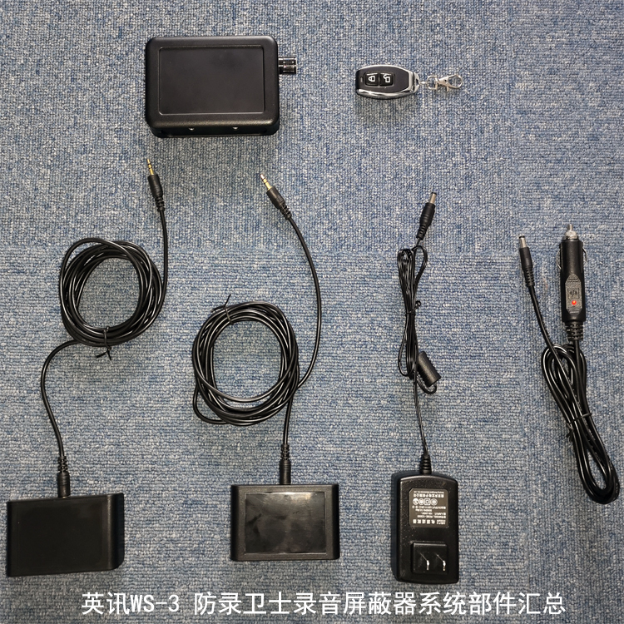

2.设备部件介绍
2. Introduction of Equipment Units

使用说明
Instructions
拿到本产品后先检查包装内：主机一台；扩展器两个； 电源适配器两个；连接线两根；遥控器一个。
After getting the product, check the package: one host, two expanders, two power adapters, two connecting wires.
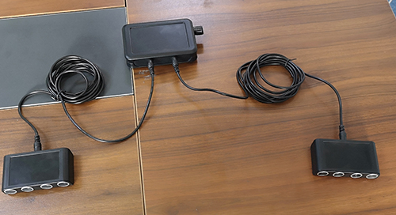
- 设备连接及开机Equipment connection and boot-up
拿到主机取出专用连接线，将连接线一端插入主机前面的扩展器接口，另一端插入扩展器上面的接口，将两个扩展器连好后，插上电源适配器通电，主机蓝色指示灯亮起，拧开关旋钮（听到咔的一声即可，不要上来拧到最大），主机红色指示灯亮起，机器进入待机状态，按遥控器上的开锁按钮开机。
特别注意：
- 拧开关时拧开即可，不要上来就把功率调到最大，遥控开机后，再拧旋钮调整功率！
- 严禁机器工作中物理插拔扩展器，应用遥控关机后插拔，再用遥控器开机。
Hold the main engine, take out the special connection line, insert one end of the connection line into the expander interface in front of the main engine, and the other end into the interface above the expander. After connecting the two expanders, plug in the power adapter, turn on the red indicator light of the main engine by turning on the switch knob, the machine enters the standby state, and press the unlock button on the remote controller to start the machine.
2.设备使用Use equipment

开机后根据使用场景调整扩展器的位置和角度固定，扩展器作用区域不要有障碍物阻挡，扩展器的摆放原则参考下图及视频，（https://cloud.video.taobao.com//play/u/3694981476/p/1/e/6/t/1/218093784311.mp4 (拷贝地址到浏览器地址栏播放)(Copy address to browser address bar)
）扩展器放置完毕，用录音设备测试，并调节功率旋钮，以达到最佳屏蔽效果为宜。
After boot-up, adjust the position and angle of the expander according to the usage scene. There should be no obstruction in front of the expander. The principle of placing the expander refers to the following figure and video. After placing the expander, the expander is tested with recording equipment and the power knob is adjusted to achieve the best shielding effect.
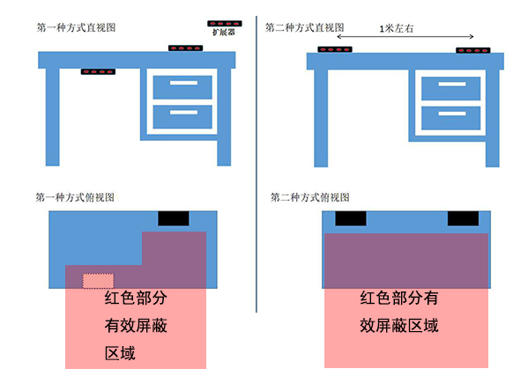
特别注意：如果本款录音屏蔽系统对个别录音设备屏蔽效果不理想，建议采用两套即可解决！
3.应用场合
3.Applications
本款WS-3录音屏蔽器是由天津市英讯科技有限公司自主研发的，高度集成化的高科技安全防护产品。当不法分子采用录音设备（如手机、录音笔、录音机等）对您进行录音时，录音屏蔽器会产生随机性的噪音信号，该信号能够对语音信号产生压制性干扰，使录音设备拾取的只有噪声信息，而无法分辨出语音信息，从而确保语音信息的安全。广泛应用于：领导办公室、保密会议室、军事作战室、商务谈判室等一切防止录音的场所。
This WS-3 recording shield independently researched and developed by Tianjin Yingxun Technology Ltd, is a high-tech safety protective apparatus with high level of integration. In case of being illegally recorded via recording devices (such as mobile phones, recording pens and recorders and so on), the recording shield will generate random noise signals which can oppressively interfere with speech signals so that only noise information is picked up by recording devices and the speech information cannot be distinguished to make sure of safety of speech information. Generally applied: head office, confidential meeting room, military operation room, business negotiation room and any other places which need to be protected from being recorded.
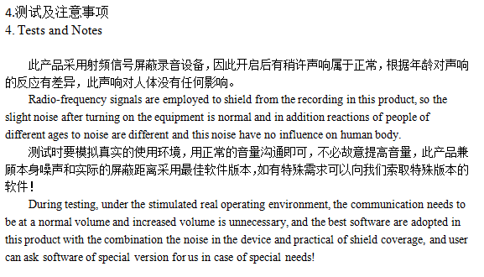
注意：桌面型录音屏蔽器的发射端子正对录音设备的时候屏蔽效果最好。
Notes: there will be best effect of shielding when emission terminals of desktop recording shield are directly facing recording devices.

技术参数（WS-3）
Technical Parameters (WS-3)

项目 | 性能参数
屏蔽设备类型 | 手机、数码录音笔、录音机一切声音采集的设备
屏蔽效果 | 83%以上
屏蔽距离 | 1-2m
屏蔽角度 | 90-120度
重量 | 250克
产品尺寸 | 122*78*27mm
供电模式 | 适配器
工作电流 | 0.1A
干扰模式 | 声学干扰
干扰强度 | 85dB
工作时间 | 8小时
工作温度 | -30℃～40℃
外壳材质 | 注塑
配件 | 主机、扩展器、电源设配器、专用连接线、设备包装箱

Items | Performance parameters
Shielding objects | Mobile phones, digital recording pens, recorders and any other device for sound acquisition
Shielding effect | Above 83%
Shielding distance | 1-2m
Shielding angles | Horizontal 90°-120°/vertical 90°-120°
Weight | 250g
Size of product | 122*78*27mm
Power supply mode | Built-in battery/power adapter
Operating current | 0.1A
Interference mode | Acoustic interference
Interference strength | 85dB
Operating temperature | -30℃～40℃
Material of shell | Plastic
fittings | Host, expander, power allocator, special connection line, equipment packing box

安全注意事项
Safety Cautions
使用前请仔细阅读以下安全注意事项：
Carefully read the following safety cautions before use:
发生以下情况请立即关闭设备，从电源插座中拔出电源设配器。
In case of the following circumstances, turn off equipment immediately and plug power adapter out of the outlet.
1.停电或者电压不稳定
1. Power failure or voltage instability
2.设备内部发出异常声音后者气味
2. Abnormal noise or smell from the inside of equipment
3.电源设配器损坏
3. Damages to power adapter
4.设备由于跌落、敲击、撞击而损坏
4. Damages to equipment due to falling off, being knocked on and being impacted
5.任何液体或其它异物调入机壳内
5. Falling of any other fluid or foreign bodies into the shell
温馨提示
Warm Warning

切勿使用交流220V、50Hz以外的电源。

1. Don’t use any other power supply other than 220V AC, 50 Hz.

切勿改装或者损坏设备及电源设配器。

2. Don’t refit or damage equipment and power adapter.

切勿用其它电源设配器对设备进行充电。

3. Don’t employ other power adapter to charge the equipment.

切勿以任何方式自行拆装设备，所有修理都应委托专业的技术人员。

4. Don’t assemble and disassemble equipment in any way by yourself, and all of repair should be consigned to professional technicians.

演示视频地址

Website of Demo Video

https://cloud.video.taobao.com//play/u/3694981476/p/1/e/6/t/1/218093784311.mp4 (拷贝地址到浏览器地址栏播放)(Copy address to browser address bar)

保修卡
尊敬的用户
您好！感谢您购买天津市英讯科技有限公司的产品，为了更好的为您服务，在购买产品后，请认证阅读，填写并妥善保管好此保修卡。
用户名 |  | 联系人
购买日期 |  | 联系电话
产品名称 |  | 产品型号
用户地址
订单编号
维  修  记  录 | 日期 | 故障原因及处理情况

保修说明
产品若出现质量问题需要维修时，请把此保修卡与所购产品一起妥善寄回我公司提供售后维修处
注意事项
- 自您选购本产品签收首日起，凡按照使用说明书安装使用，一年内出现非人为质量问题，我们提供免费维修，一年后维修只收取维修工本费。
- 非本公司产品质量原因引起的质量问题，如使用不当，保管不妥，擅自拆机等原因造成的损坏，本公司维修只收取维修工本费
- 本产品实行一年保修，内置电池一年保修。

服务联系信息：
天津市英讯科技有限公司
地址：天津市南开区宾水西道333号万豪大厦C-1510
电话：022-23728011
http://www.heroley.com

