Advanced Materials for Fuel Efficient Gas
Turbine Engines in Airplanes

Airplanes are the safest mode of transportation. However, the recent airplane crashes have raised several doubts about its safety. Our interest is to correlate advanced materials and design architectures deployed in these engines with high temperature wear and friction mechanisms leading to distress and potential failures. Read the full article and learn about turbine erosion and fretting.

Airplanes are the most secure method of transport. Although, the latest airplane
accidents have popularized many issues in terms of its safety. Initial reports show
that an airframe redesign to make space for the latest fuel efficient (15 to 20%
better) gas turbine engines may have triggered the accidents.

Ducom Instruments is committed to correlating progressive material and design
architectures installed in these engines with high temperature wear and friction
mechanisms leading to distress and potential failures.

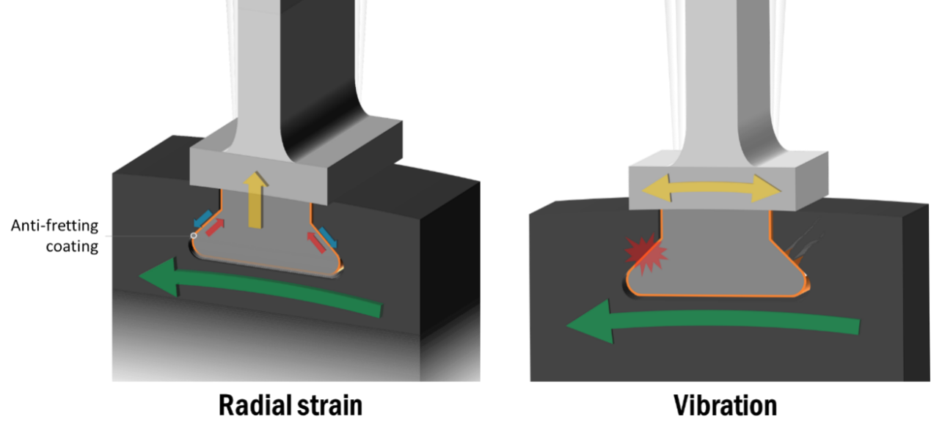
Figure 1. Ant-ifretting coatings to guard the blade root and disk slot from fretting wear (due to radial strain and vibration).

An efficient gas turbine engine (based on the Brayton cycle) must have a lower
consumption of fuel, create less noise and have a lower cost of maintenance. In this regard, there are many materials and designs that reduce weight, and promote a higher bypass ratio, along with reducing the friction and wear of engine parts.

A high bypass ratio, such as a ratio of 12:1, can be attained by utilizing a gear powered turbo fan. It produces a high amount of air near to the exhaust which increases the thrust.However, the gearbox being added can increase engine weight and create issues with reliability.

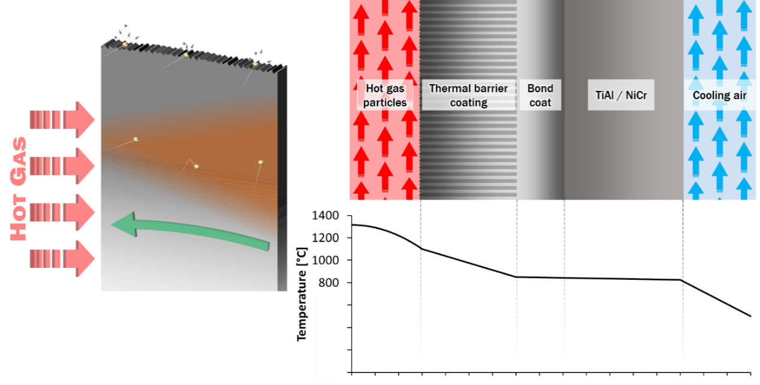
Figure 2. Thermal barrier coatings (TBCs) that defend the base alloy from erosion and heat.
To level the gearbox weight, material science was pushed to its limits in aiming to lessen the weight of the engine.

The fan blades were created from lighter aluminumlithium alloy and carbon fiber
composites, and the turbine blades were made of titanium aluminides. Titanium
aluminides are lightweight and have a greater strength in contrast to Ni-Cr alloys.

Moreover, the Ni-Cr alloys utilized in turbine shroud lining took the place of a lighter composite metal matrix, as an example, silicon carbide fibers in a carbon matrix with boron nitride coatings can cope with a temperature of 1315 °C or 2400 °F.
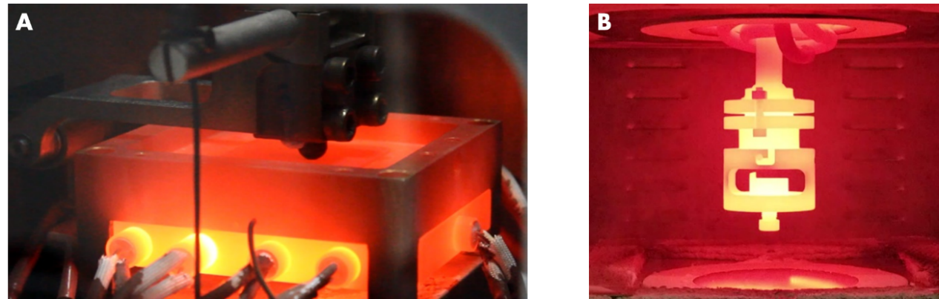
Figure 3. Image of a test area in Ducom Fretting Wear Tester (A) and Ducom Air Jet Erosion Tester (B), at a high operating temperature.

Fuel efficient gas turbines with a gear powered turbofan were also less expensive to operate. There were less parts needed for replacement because the stages or blades were fewer in number. There was also an improvement in the wear resistance behavior of the engine blades.

Ant-ifretting Cu-Ni or Cobaltbased coatings were placed on the blade root and disk slot to reduce wear from radial strain and vibration at high temperatures (as shown in Figure1).

The turbine blades were coated with thermal barrier coatings (TBCs) to guard from heat and high temperature erosion by solid particles (illustrated in Figure 2).

The wear resistance behavior of these coatings can be tested using the Ducom High Temperature Air Jet Erosion Tester operating at 1200 °C (as shown in Figure 3 B) and the Fretting Wear Tester operating at 900 °C (shown in Figure 3 B).
The characteristic erosion curves for TBCs and characteristic friction curves for antifretting coatings are demonstrated in Figure 4 and 5 respectively. The section at the end of this article describes some of the unique features of the Ducom High Temperature Tribometers.

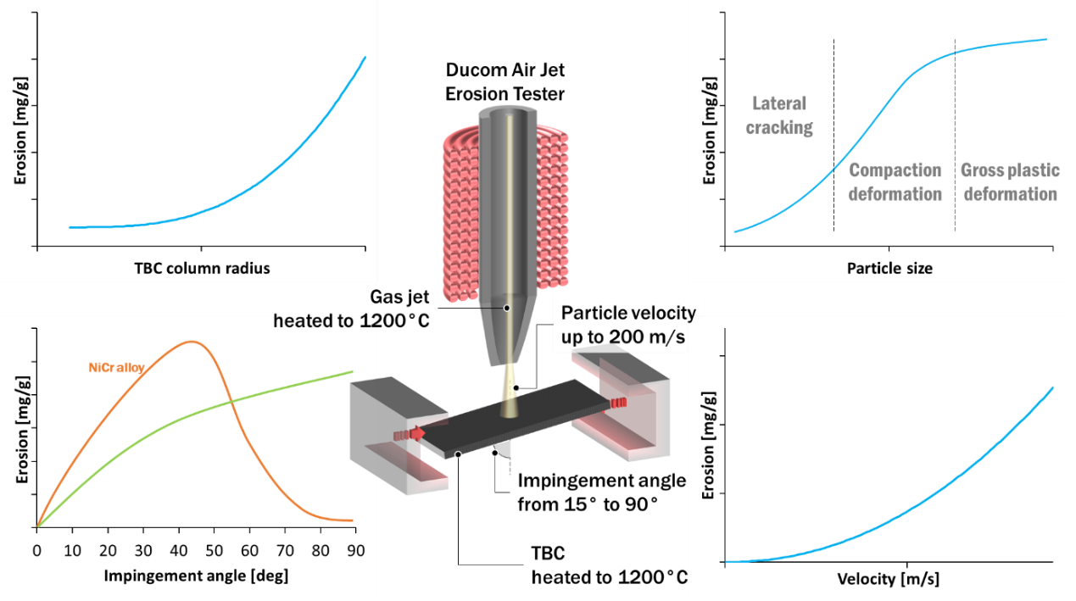
Figure 4. Characteristic erosion curves for thermal barrier coatings.
/8 3
To conclude, the technology related to gear powered turbofans lessened the expense of replacement parts, pushed the limits of material science to fashion lighter engine parts and wear resistant coatings, and attained higher thrust in contrast to engines containing standard turbofans.

While they added to a greater fuel efficiency and smaller maintenance costs, there was a critical modification to the engine dimension.

Gear powered turbofans were greater in diameter in contrast to regular turbofans which made the engines bigger. As such, the pylons were remade to enhance the ground clearance by pushing the engines towards the nose and elevating them from the ground.

This produced new obstacles in terms of the aerodynamics of the plane, and the
solutions to correct it may have caused the lethal crash. It is unfortunate that the fuel efficient engines were in some way connected to the fatal design.
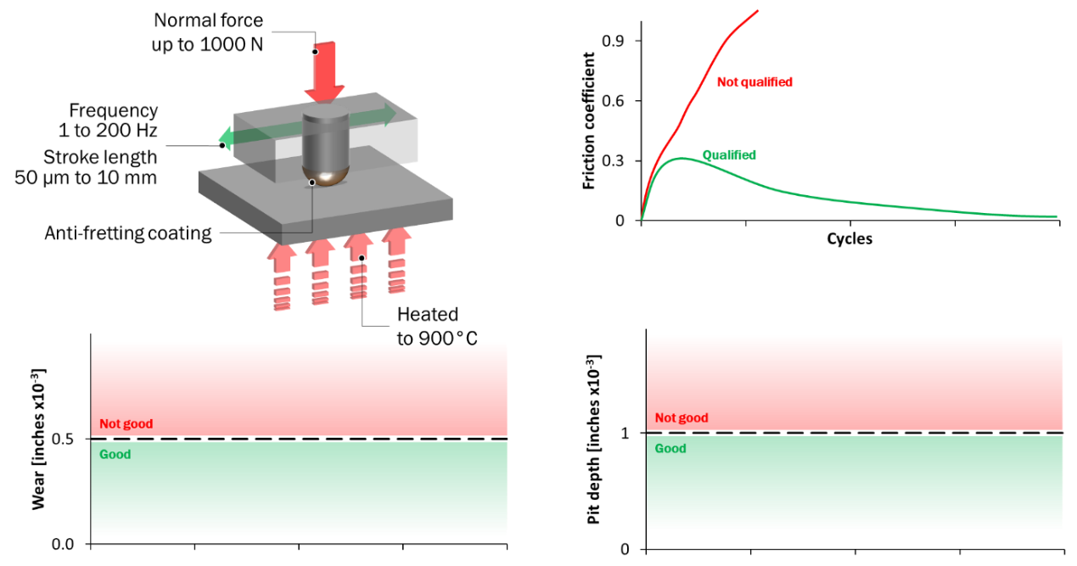
Figure 5. Characteristic performance curves for coatings under fretting conditions.

Ducom Air Jet Erosion TesterP
/8 4
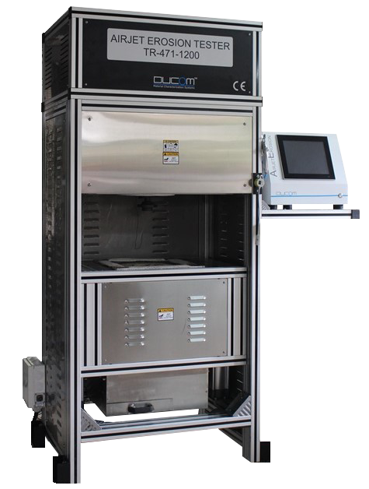
The Ducom Air Jet Erosion Tester is a distinctive laboratory facility, taking up the same space as a home refrigerator, but with the ability to test coatings under the harshest temperature environments reaching to 1200 °C and erodent velocities of 200 meters per second and more. The instrument is compliant with the ASTM G211 and G76 standards.

User benefits:

·High testing throughput of up to six erosion tests per day at 1200 °C
·Realistic gaseous environments
·Various erodent chemistries

Ducom Fretting Tester

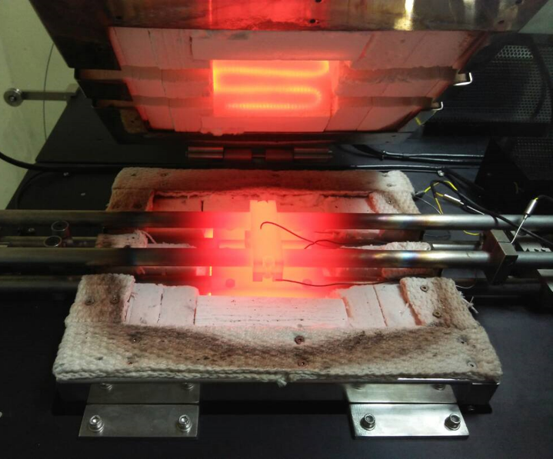
The Ducom high temperature Fretting Tester is a wholly allinclusive system capable of a varied range of frequencies (1 to 200 Hz), strokes (< 50 μm to 10 mm), loads up to 1000 N and temperatures up to 900 °C, therefore reproducing the contact pressures, micromotions and conditions occurring in turbomachinery and combustor fretting interfaces.

User benefits:

·High testing throughput of up to 10 tests per day at 900 °C per day
·Reliable pure friction force measurement
·True to life field environment conditions

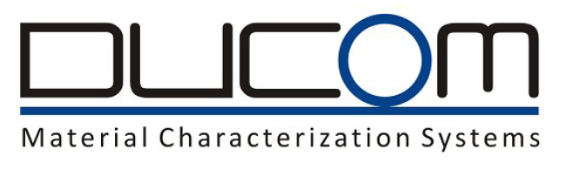
This information has been sourced, reviewed and adapted from materials provided by Ducom.

For more information on this source, please visit Ducom.
P

/8 6
Ducom Instruments leads the way in designing and manufacturing advanced materials testing instruments specializing in tribology. Through the application and implementation of cuttingedge technology as well as strong design principles to its products, Ducom focusses on providing customers with excellent ownership experiences.

Ducom instruments use components that are manufactured in an AS9100:2009 certified “aerospace grade” manufacturing facility for excellent quality.

Our instruments are operational and recognizeable all over the world. Leading Research labs working on cutting edge technology development which requires advanced and highly configurable test systems to standardized quality control requirements which rely on highly repeatable systems to accurately monitor product quality test instruments by Ducom.
Primary Activity/8 7

Material Manufacturer
Manufacturer of test instruments for mechanical characterization
P
/8 8

