The 4th International Symposium on Lipid Science and Health

(First Announcement)

Lipid is one of the three major nutrients of human beings and plays an important role in human nutrition and health. The structure and composition of lipids are closely related to their biological functions and nutritional quality. Lipid has been becoming a hotspot for health and nutrition research all over the world. The International Symposium on Lipid Science and Health (ISLSH), which was organized annually by Oil Crops Research Institute of Chinese Academy of Agricultural Sciences (OCRI-CAAS) since 2016, has gained a strong reputation and attracted hundreds of delegates from around the world for discussion of lipid research trends and advances every year. In order to further promote the rapid development of lipid science and health research and enhance academic communications, The 4th International Symposium on Lipid Science and Health (4th ISLSH) will be held. The organizing committee will invite well-known experts specialized in lipid science all over the world to share the up-to-date achievements and prospects that cover the topics regarding lipid profiling methods, lipid preparation and modification, lipid improvement and regulation and lipid metabolism and health. We sincerely invite all experts and scholars to attend the conference.
I. Organizers
Host Unit:
Oil Crops Research Institute of Chinese Academy of Agricultural Sciences
Oil Crops Committee of the Crop Science Society of China
CABIO Biotech (Wuhan) co., Ltd
Co-Host Unit:
National Health Oil Industry Technology Innovation Alliance
OCRI-INFINITUS Joint Laboratory for the Research of Functional Lipids
II. Topics to be covered
- Lipid Profiling Methods
- Lipid Preparation and Modification
- Lipid Improvement and Regulation
- Lipid Metabolism and Health
III. Time & venue
Time: November 15th-16th for symposium and November 14th for check-in.
Venue: Oil Crops Research Institute of Chinese Academy of Agricultural Sciences
(Xudong 2nd Road, Wuhan, Hubei, P.R. China)
IV. Plenary speakers
- Well-known experts specialized in lipid science all over the world.
- Authors of selected outstanding abstracts.
V. Registration information
1. Registration fees
Registration types | Early bird registration  ( before October 25) | Standard registration  (October 26-November 14)
Regular registration | 1400 RMB | 1600 RMB
Student registration | 1000 RMB | 1200 RMB
On-site registration is available. The registration fees will be spent on the conference arrangements, including materials, venue, reception and meals.
Student registration is available for those studying full time and who hold a current Student Identification Card.
Accommodation and travel expenses are additional to the registration fees.
2. Payment of registration fees
Payee: Oil Crops Research Institute of Chinese Academy of Agricultural Sciences
Account number: 421862188018001045286
Name of bank: Xudong Branch, Wuhan, Bank of Communication
Remittance notes: The 4th International Symposium on Lipid Science and Health
and name of attendee
Please send us the payment voucher through E-mail (lipidscience@163.com) if you transfer money online in advance. The invoice of registration fee would be gotten when checking in.
VI. Sponsorship
Any sponsorships from enterprises and companies will be welcomed. For information on exhibition and sponsorship opportunities at the conference, please contact the organizing committee.（Xin Lv Tel: 15207162135, E-mail: lvxin_1003@163.com）
VII. Contribution
1. Call for abstracts
You are invited to submit an abstract to be reviewed for inclusion in the symposium program as either an oral or a poster presentation. Abstract submitted should describe work that has not been published or presented at another national or international meeting and should be limited to 300-500 words. The deadline for abstract submission is October 25th, 2019. The Return Receipt and Abstract Submission Format are attached below. Abstracts and return receipt should be sent to the mailbox: lipidscience@163.com.
2.Special issue articles
Conference organizers plan to launch a special issue on the English journal OIL CROP SCIENCE (expected to be published in December of 2019). Full length research articles and reviews that have not been published elsewhere are considered for publication after the journal editorial office and peer review process. The length should not normally exceed 8000 words. Manuscripts should be submitted online at http://www.journalocs.org. A guide for authors and manuscript templates for submission are available on the home page of http://www.journalocs.org. The deadline for submission of manuscripts is October 30th, 2019.
VIII. Local Organizing Committee Contacts
Address:
Room 603, Scientific Research Main Building, Oil Crops Research Institute of Chinese, Academy of Agricultural Sciences, Xudong 2nd Road, Wuchang District, Wuhan, Hubei, P.R. China
Committee secretariat:
Fang Wei 027-86711669 15827146940
Mingming Zheng 027-86827874 13163317335
Qianchun Deng 027-86827874 18696198198
Conference mailbox:
lipidscience@sina.com
IX. Poster Presentation and Outstanding Poster Awards
1.Poster Presentation
As a main part of the symposium, poster presentation is also one of the most crucial forms of academic exchange. Posters should be made standardly and research results should be presented with visual graphs and tables, which are matched with succinct explanation. Research innovative points should be embodied in the content. Attentions need to be paid on are as follows:
- Language: English;
- Poster size will be limited in height×width: 110cm×80cm;
- Innovativeness, methods and results of the research should be highlighted in the poster.
2.Outstanding Poster Awards
In order to encourage academic exchange, conference organizing committee will set Outstanding Poster Awards for researchers who make excellent poster presentation in the symposium; the committee will organize experts to evaluate all of the posters. Certificates of excellent posters and bonus will be awarded to prize winners, among which there will be 1 first prize, 2 second prizes and 3 third prizes, the bonuses for each level are 1200 RMB, 1000 RMB and 800 RMB, respectively. Please fill out the title of your poster in the return receipt.

OCRI-CAAS
June 24th, 2019

Contact us:
Conference WeChat Group: The International Symposium on Lipid Science and
Health
Conference WeChat Official Accounts: The International Symposium on Lipid
Science and Health
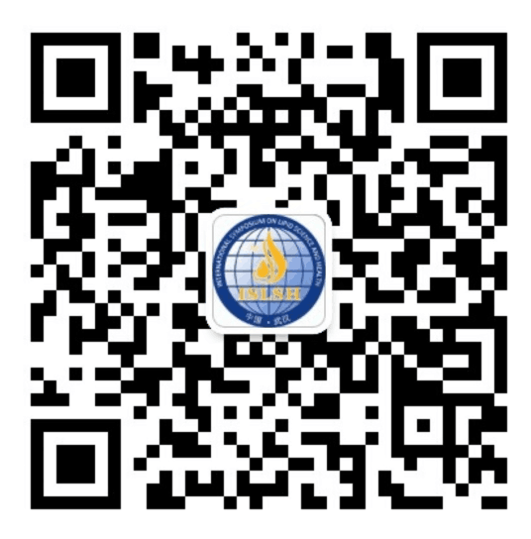
Conference QR Code:

Annex I Return Receipt
Annex II Reference Template of Abstract

