Atmos ™全新金属气体池系列
解决化学腐蚀以及复杂性气体的分析
特点：
- 固定光程从2.5米到20米
- 金属外壳加特殊镀层
- 容积≈0.5L for 5m and ≈0.2L for 2.5m, ≈2L for 10m, < 5 L for 20m
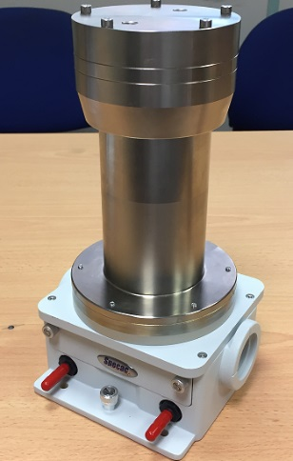
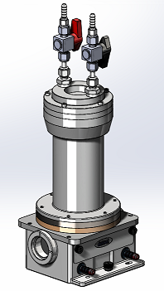
- 可选K型全氟橡胶密封圈针对强化学腐蚀气体
- 更高压力(metal body) : 120psi
- 真空度: 10⁻⁴ torr
- CaF2, ZnSe 窗片
- 不锈钢金镜
- 无支架设计
- 光通量提高多倍
Atmos 气体池
Atmos 气体池是解决混气,电子气,化学腐蚀性强的气体的理想选择
Atmos 气体池系列有四个尺寸：
- Atmos 气体池 2.5米,5米,10米,20米
Tornado™ 系列气体池使用特殊的底板配置系统,可将能量和光束耦合达到最佳方式

选用主体材料为金属材质腔体,内壁镀层，可针对多种气体和蒸汽提供优越的耐腐蚀性。标准配置有V型密封圈以及可选K型全氟橡胶密封确保在长时间化学腐蚀以及气体的冷凝后的强腐蚀性条件下依旧保持良好的密封。
金镜材质抛弃了原有的铝材质,选用更加不易变形的不锈钢材质,在针对化学腐蚀,稳定性,以及冷热影响方面,更加稳定,数据结果更加真实可靠.
Atmos 气体池的反射次数比原有的型号减小,使得光通量更高.2.5米池的光通量可达到40%.
无镜架设计使得,内部不在会有更多被腐蚀的因素存在.
可选择ZnSe 或CaF2窗片材料，透射光学腔体安装有清洁端口允许在惰性气体条件下使用。
光程 | 容积 | 光通量
2.5M | 0.2L | 40%
5M | 0.5L | 30%
10M | 2L | 20%
20M | 4L | 10%

技术参数

参数 | Atmos 2.5 | Atmos 5 | Atmos 10 | Atmos 20 | 单位
Nominal Path Length | 2.5 | 5.0 | 10 | 20 | mm
内部反射镜距离 | 104 | 139 | 250 | 455 | mm
内部直径 | 50 | 68 | 96 | 96 | mm
反射次数 | 24 | 36 | 40 | 44
最小光程长度 | 2.50 | 5.00 | 10.0 | 20.0 | mm
容积 (between mirrors) | 0.20 | 0.50 | 1.8 | 3.3 | l
附容积 | 0.026 | 0.074 | 0.166 | 0.166 | l
容积 | 0.23 | 0.59 | 2.0 | 3.5 | l
通量(detector/accessory entrance) | 39 | 32 | 21 | 11 | %
壁厚 | 12.5 | 12.5 | 12.5 | 12.5 | mm
到连接头顶部的长度 | 80 | 80 | 80 | 80 | mm
外部直径 | 75 | 93 | 121 | 121 | mm
外部长度 | 184 | 219 | 330 | 535 | mm

订购信息

GS24602CV | Atmos 2.5M Pathlength Metal Bodied Gas Cell with CaF2 Windows and Viton seals.
GS24602CX | Atmos 2.5M Pathlength Metal Bodied Gas Cell with CaF2 Windows and Kalrez seals.
GS24602ZV | Atmos 2.5M Pathlength Metal Bodied Gas Cell with ZnSe Windows and Viton seals.
GS24602ZX | Atmos 2.5M Pathlength Metal Bodied Gas Cell with ZnSe Windows and Kalrez seals.
GS24605CV | Atmos 5M Pathlength Metal Bodied Gas Cell with CaF2 Windows and Viton seals.
GS24605CX | Atmos 5M Pathlength Metal Bodied Gas Cell with CaF2 Windows and Kalrez seals.
GS24605ZV | Atmos 5M Pathlength Metal Bodied Gas Cell with ZnSe Windows and Viton seals.
GS24605ZX | Atmos 5M Pathlength Metal Bodied Gas Cell with ZnSe Windows and Kalrez seals.
GS24610CV | Atmos 10M Pathlength Metal Bodied Gas Cell with CaF2 Windows and Viton seals.
GS24610CX | Atmos 10M Pathlength Metal Bodied Gas Cell with CaF2 Windows and Kalrez seals.
GS24610ZV | Atmos 10M Pathlength Metal Bodied Gas Cell with ZnSe Windows and Viton seals.
GS24610ZX | Atmos 10M Pathlength Metal Bodied Gas Cell with ZnSe Windows and Kalrez seals.
GS24620CV | Atmos 20M Pathlength Metal Bodied Gas Cell with CaF2 Windows and Viton seals.
GS24620CX | Atmos 20M Pathlength Metal Bodied Gas Cell with CaF2 Windows and Kalrez seals.
GS24620ZV | Atmos 20M Pathlength Metal Bodied Gas Cell with ZnSe Windows and Viton seals.
GS24620ZX | Atmos 20M Pathlength Metal Bodied Gas Cell with ZnSe Windows and Kalrez seals.

