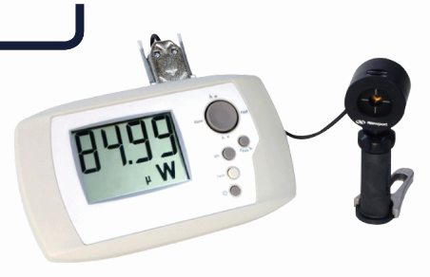
仪器货号：NP190

仪器产地：美国
Specifications
Spectral Range 190 nm to 11μm
Maximum Power 10 W
Minimum Power 1 mW
Minimum Energy 0.1 mJ
Probe Aperture 12 mm diameter
Accruacy ±2.5 %
Repeatability ±0.5 %
Resolution ±0.5 %

